Activity 8.2.3b Practice with Resultant Vectors
In other activities, you have seen how to combine vectors. This activity will give you some additional practice generating resultant vectors both graphically and algebraically.
When doing vectors, algebraically, remember, it is easiest to consider the x-direction and y-direction forces, Rx and Ry
PART I: In each of the following, consider two forces acting on an object. Each force has a direction and magnitude, measured in the given units. Algebraically, find the direction and magnitude of the resultant vector, accurate to the nearest tenth. An example has been provided as a model for you.
Example: Vector A: 40 N @ 30o SE Vector B: 60 N @ 70o SW
Ax = 40 cos 30 = 34.64 Bx = -60 cos 70 = -20.52 Rx = 14.12
Ay = -40 sin 30 = -20.00 By = -60 sin 70 = -56.38 Ry = -76.38

R2 = Rx2 + Ry2 = (14.12)2 + (-76.38)2 = 6033.28 R= $\sqrt{6033.28}$ = 77.7 N
Θ = Tan-1(76.38/14.12) = 79.5o SE
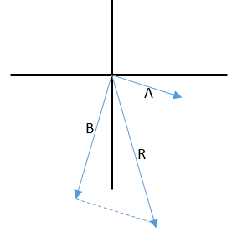
Solution: R = 77.7 N @ 79.5º SE

Now, you try:

- A = 35 N @ 60º NE, B = 50 N @ 20º NW
- A = 70 m/s @ 60º SW, B = 50 m/s @ 70º NW
- A = 40 m @ 60º SE, B = 80 m @ 30º SE
- A = 15 lb @ 60º NE, B = 50 lb @ 20º SE
- A = 35 N @ 40º SW, B = 65 N @ 20º NW, C = 65 N @ 20º NE

* You will need a protractor to do this portion of the activity. *

Part II: Using either the “tip-to-tail” graphical method, construct the resultant vectors for the 5 problems from above. Use a scale of 1cm = 10 units. Measure the magnitude and direction of the resultant and compare with your calculated results. Label vectors properly!

