Unit 1: Investigation 3 (2 Days)

Angles and Rotations

Common Core State Standards

- G-CO.1. Know precise definitions of angle, circle, perpendicular line, parallel line, and line segment, based on the undefined notions of point, line, distance along a line, and distance around a circular arc.
- G-CO.2. Represent transformations in the plane using, e.g., transparencies and geometry software; describe transformations as functions that take points in the plane as inputs and give other points as outputs. Compare transformations that preserve distance and angle to those that do not (e.g., translation versus horizontal stretch).
- G-CO.4. Develop definitions of rotations, reflections, and translations in terms of angles, circles, perpendicular lines, parallel lines, and line segments.
- G-CO.5. Given a geometric figure and a rotation, reflection, or translation, draw the transformed figure using, e.g., graph paper, tracing paper, or geometry software. Specify a sequence of transformations that will carry a given figure onto another.
- G-GPE.7. Use coordinates to compute perimeters of polygons and areas of triangles and rectangles, e.g., using the distance formula.

Overview

The investigation starts with an exploration of runway numbers used in airports. Students will discover that numbers correspond to the direction of approach relative to North, and that the angle of the direction is measured clockwise from North. This introduces the idea that directed angles and can be considered clockwise or counterclockwise. Angles are formed by two rays with a common endpoint, but each angle has two measures, the common one which is less than or equal to 180° as well as the measure greater than or equal to 180° associated with the “reflex angle.” It is this notion of rotations being either clockwise or counterclockwise that leads to the two different angle formations and measures.

This is important because Geogebra measures the angle determined by its points in counter-clockwise order. For example, below we created 3 points A, B, and C. We then selected the angle feature in the angle tab and click on A, then B, then C. In the Algebra View of Geogebra, you will notice the angle formed is the reflex angle ABC and its measure is over 180°. It calls the angle α and lists its measure as 284.76°. Now, if you create an angle by selecting C, then B, then A, Geogebra returns the value of 75.24°.

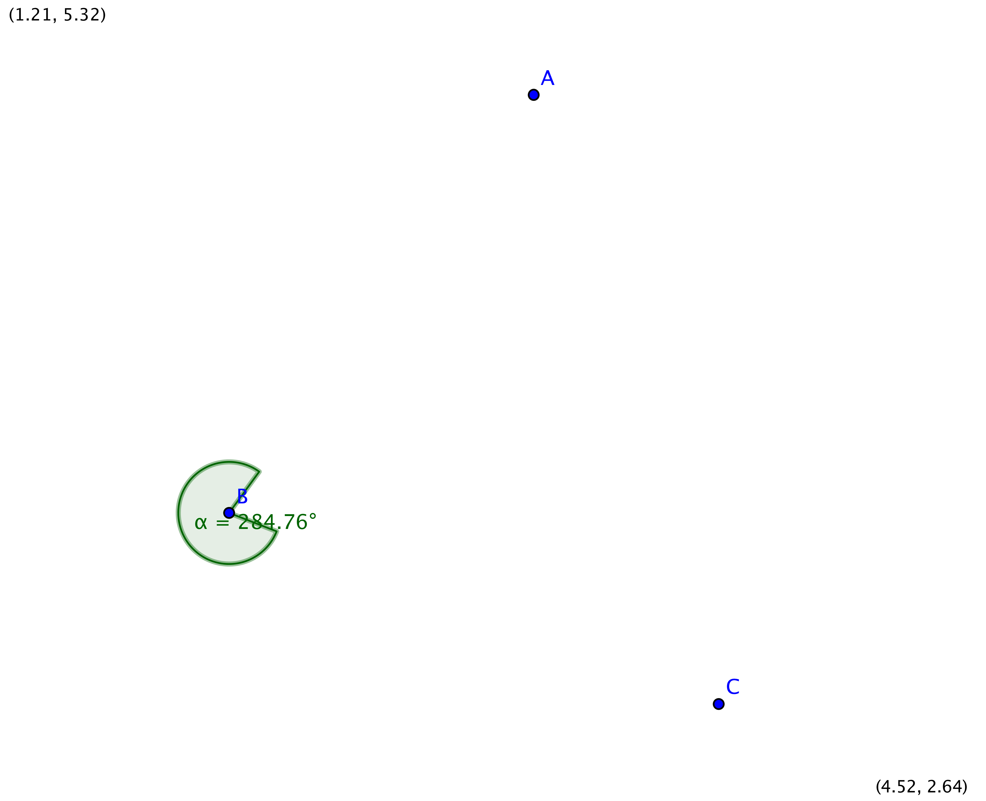
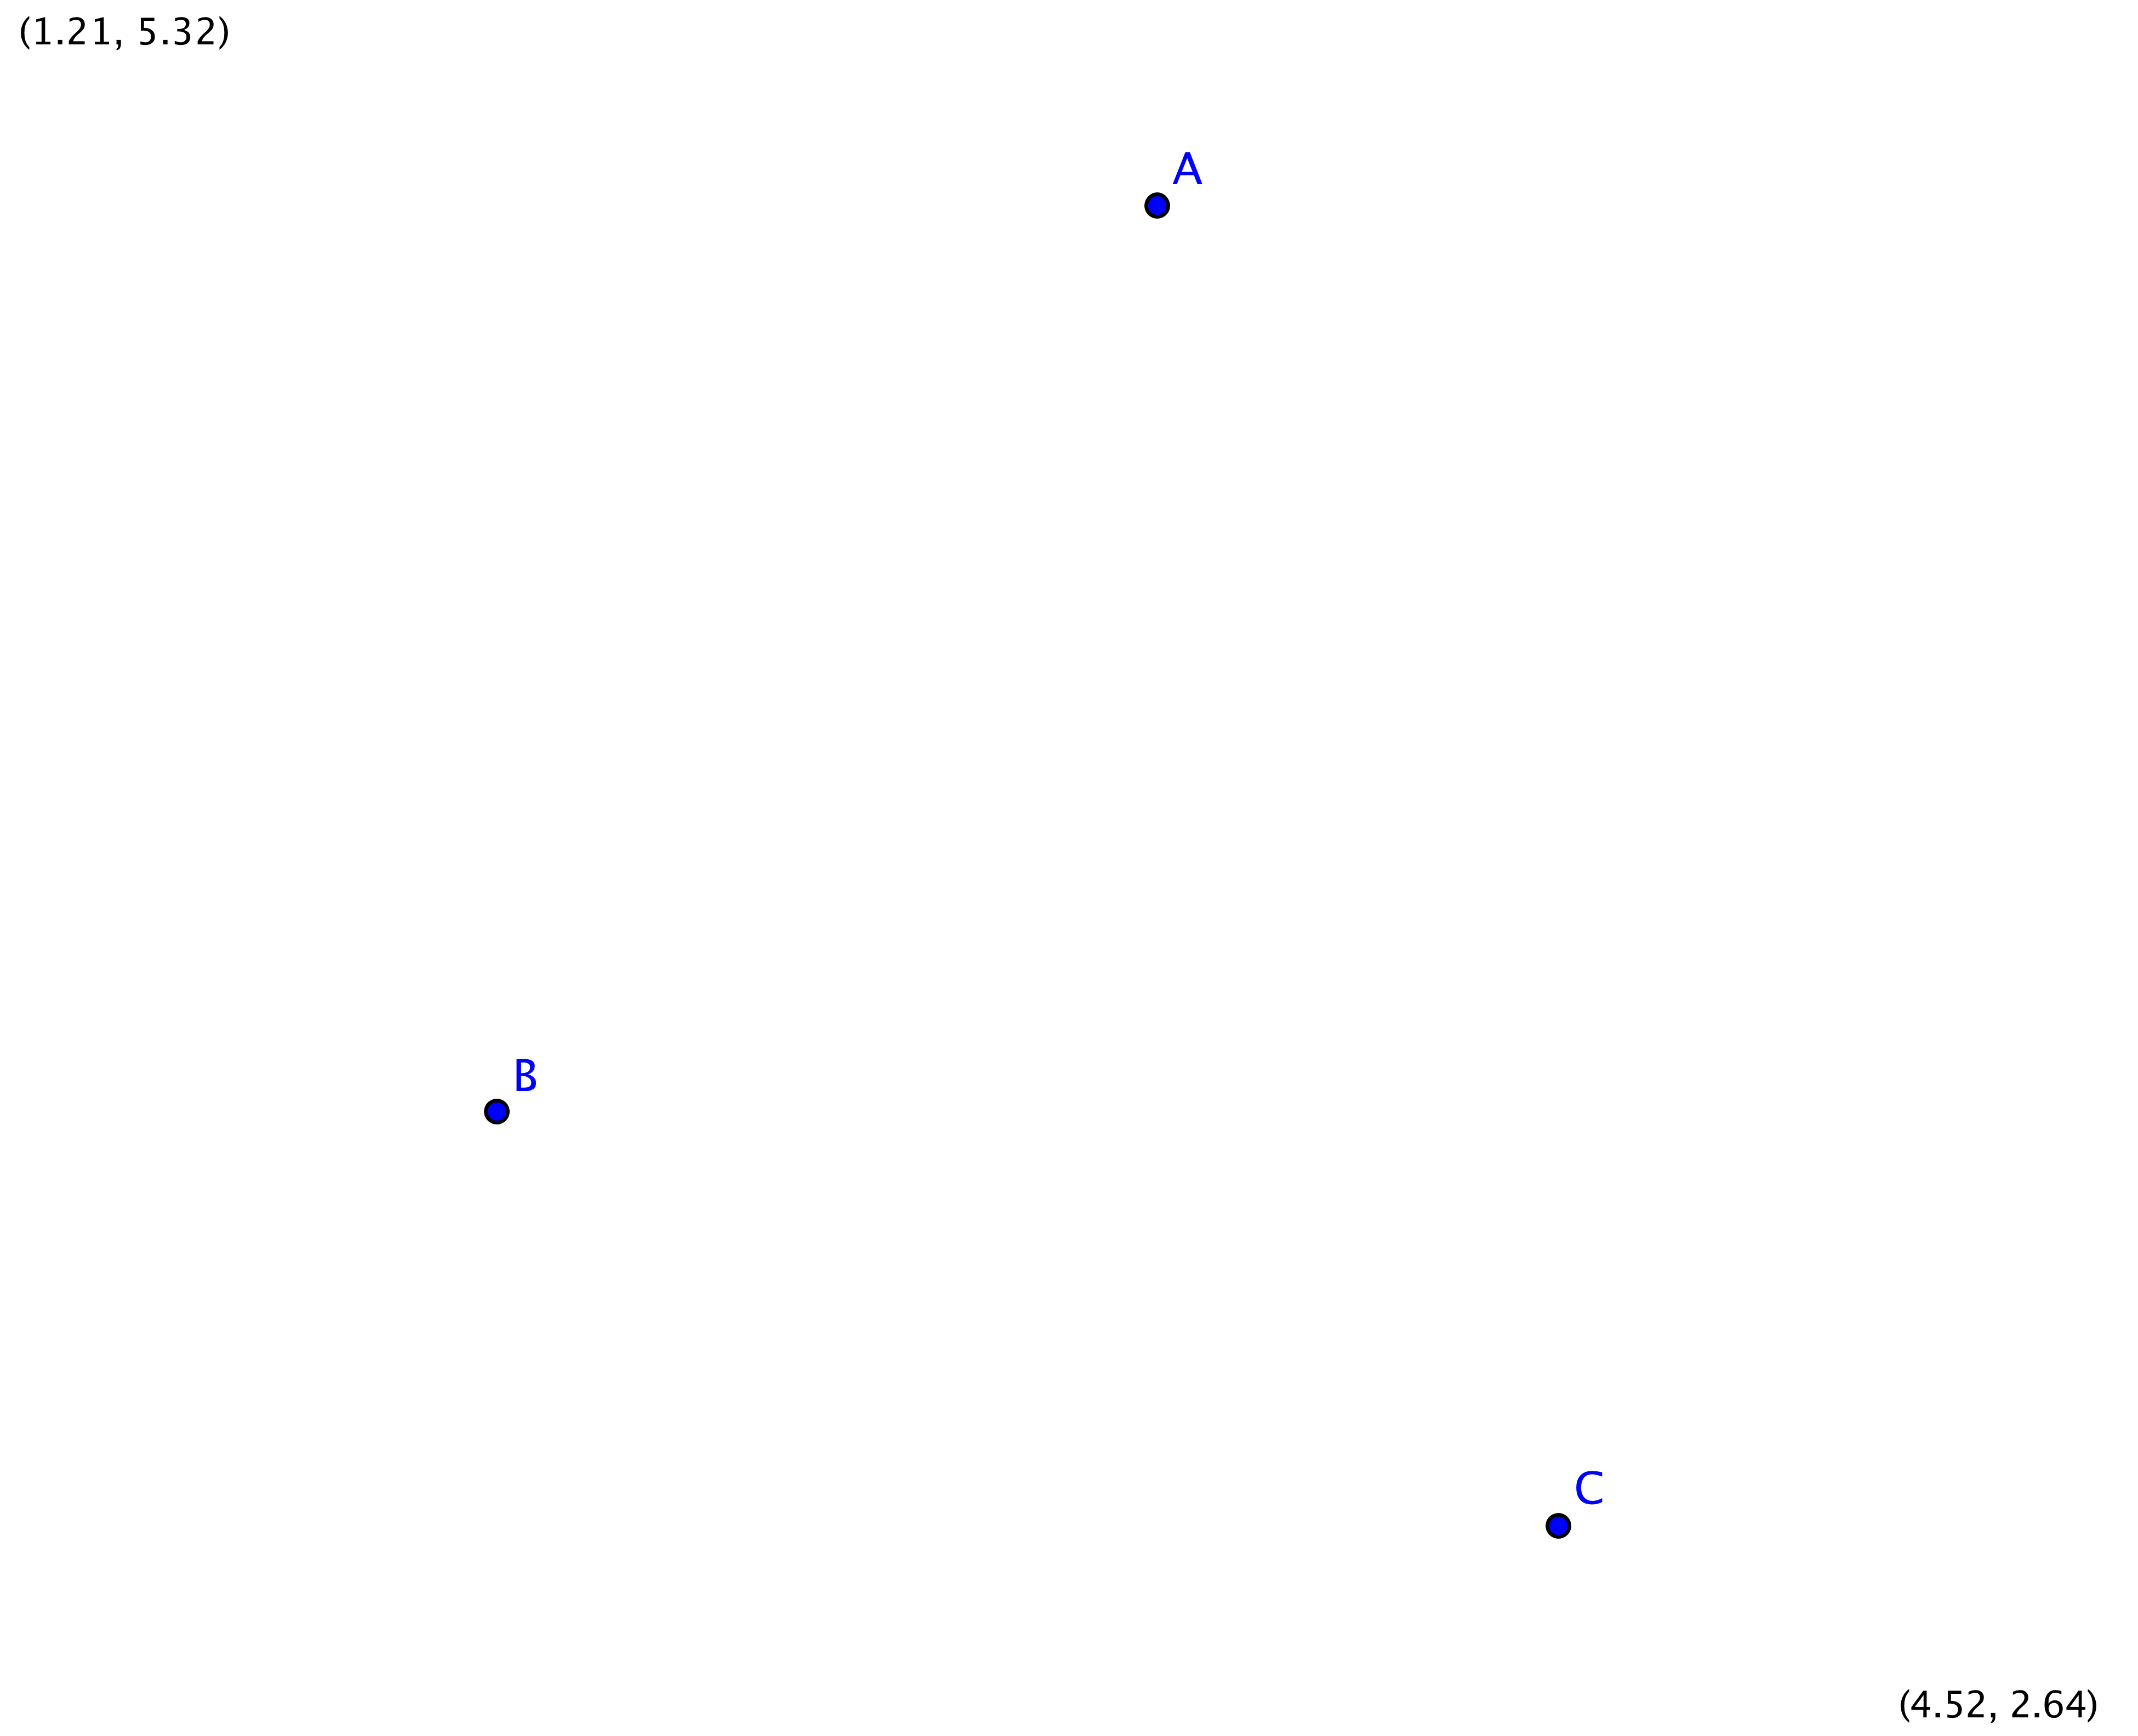
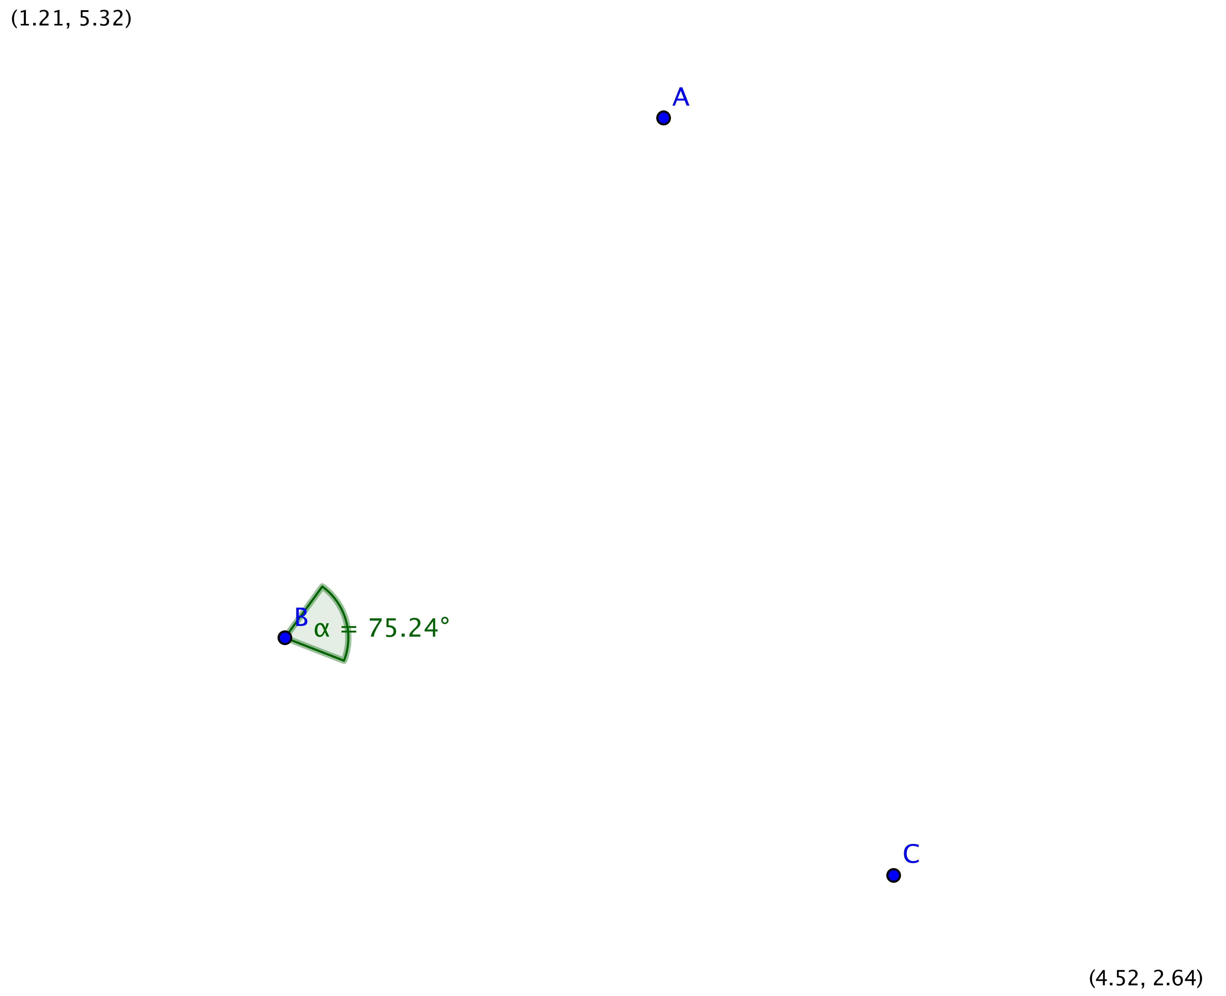

Once the concept of directed angle has been introduced students will go on to revisit the slope criteria for perpendicular lines. The transformations known as rotations are characterized by a center about which points are rotated as well as the angle and direction of rotation.

Assessment Activities

Evidence of Success: What Will Students Be Able to Do?

- Rotate an object either clockwise or counterclockwise
- Use both clockwise and counterclockwise rotations to determine the measures of angles and reflex angles
- Applying the slope criteria for perpendicular lines
- Apply mapping rules to figures in the coordinate plane for rotations of 90°, 180° and 270° counter-clockwise about the origin.

Assessment Strategies: How Will They Show What They Know?

- Exit Slip 1.3.1 asks students to measure an obtuse angle and the reflex angle associated with it.
- Exit Slip 1.3.2 asks students to rotate a polygon 90°.
- Journal Entry asks students to explain why the numbers at either end of a runway differ by 18

Launch Notes

Show students a few of the pictures below of actual runways and ask them to make observations regarding the similarities and differences between the three. Direct the discussion to the numbers. You want them to question what the numbers mean. Some students should also recognize that there is an ‘L’ on one of the runways. Ask what they might represent.

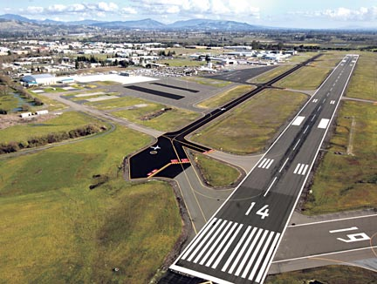
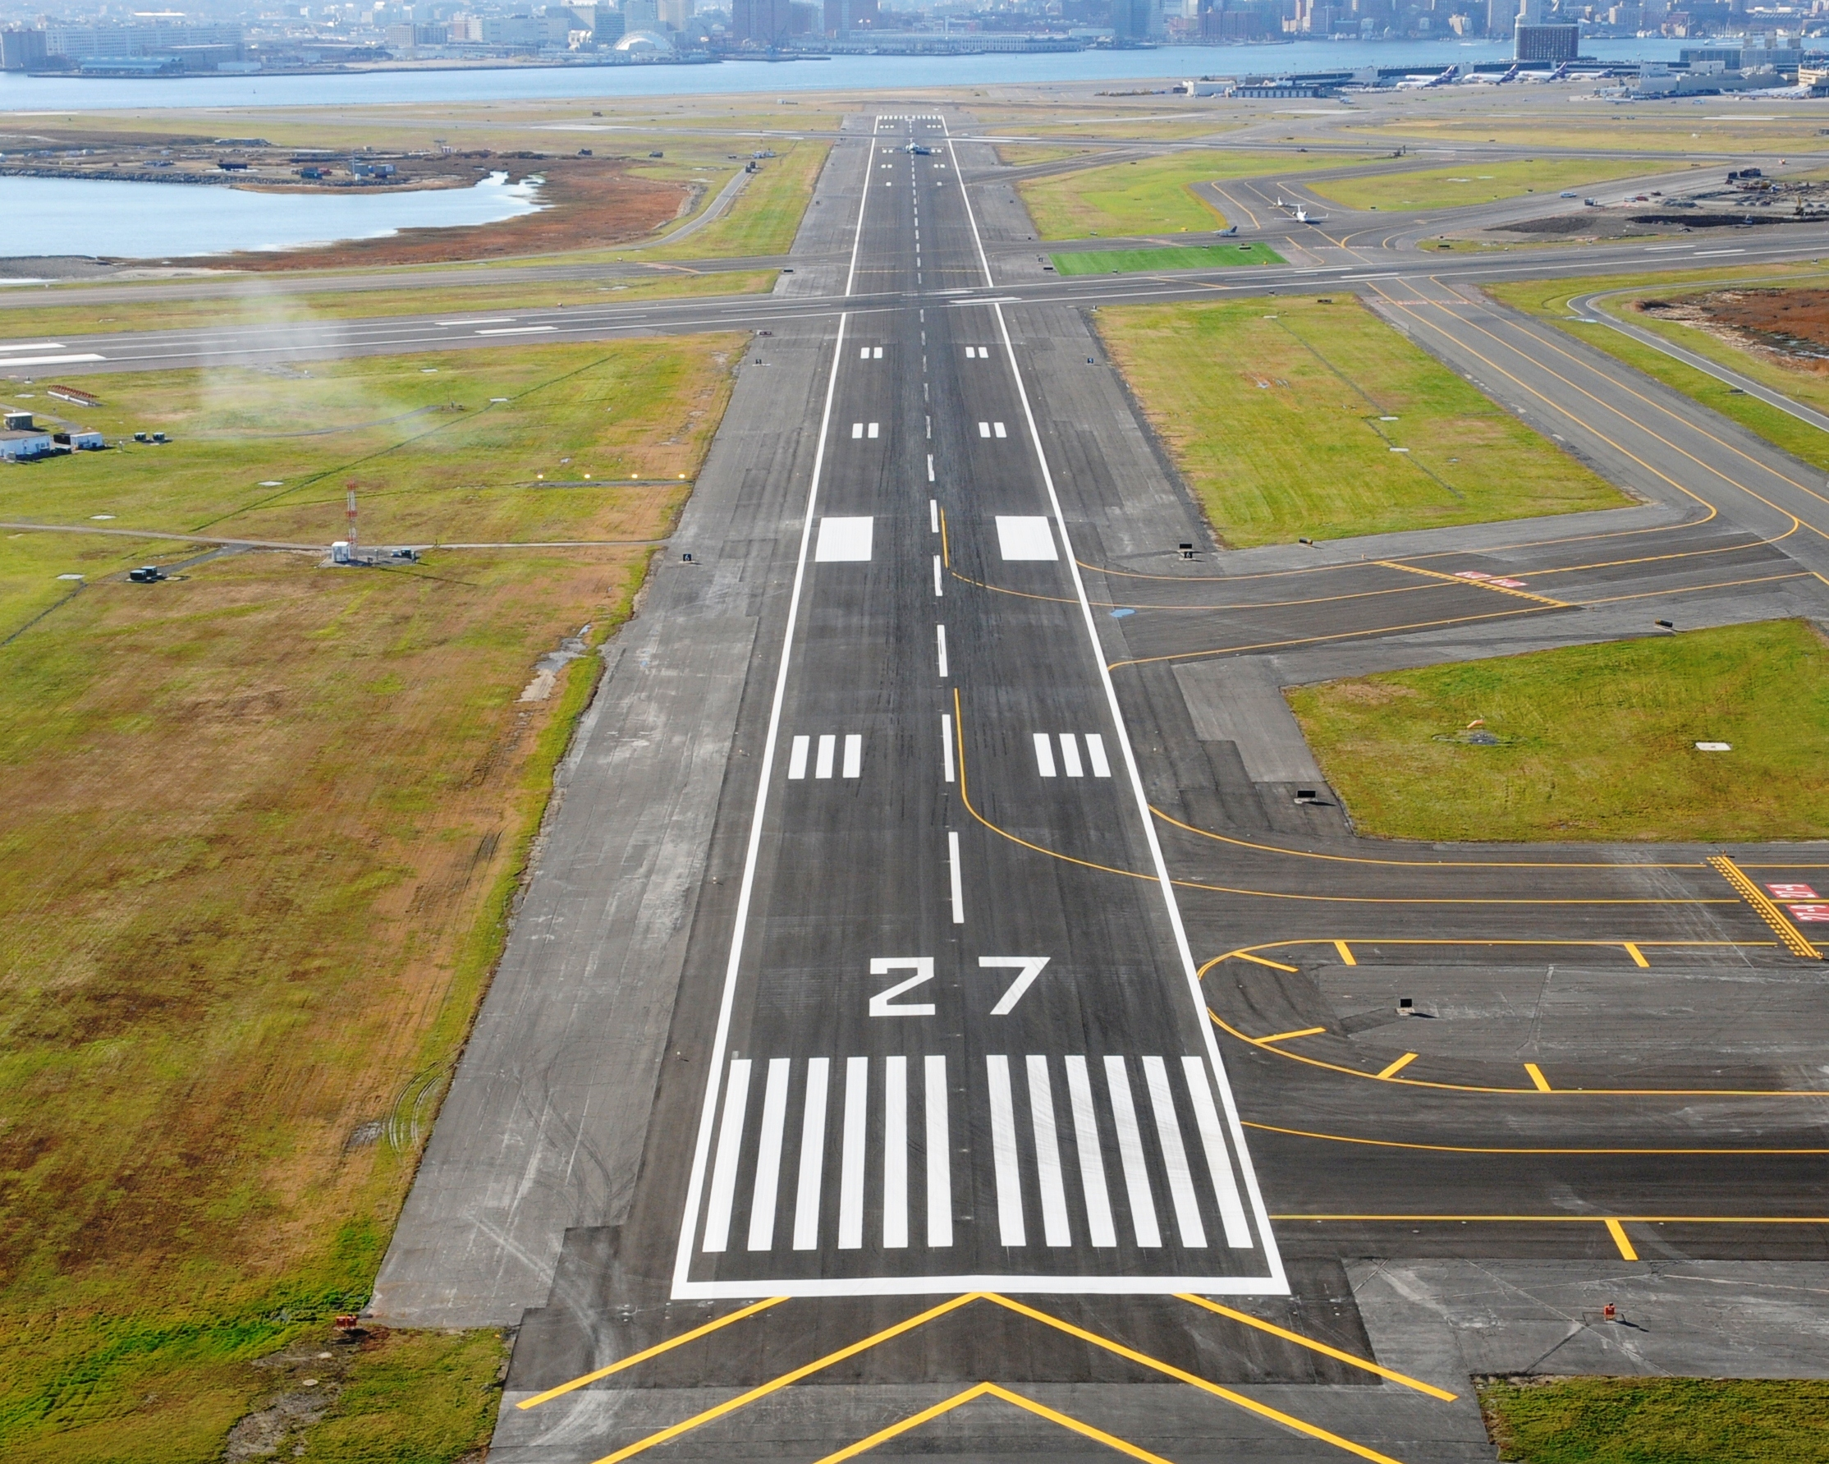

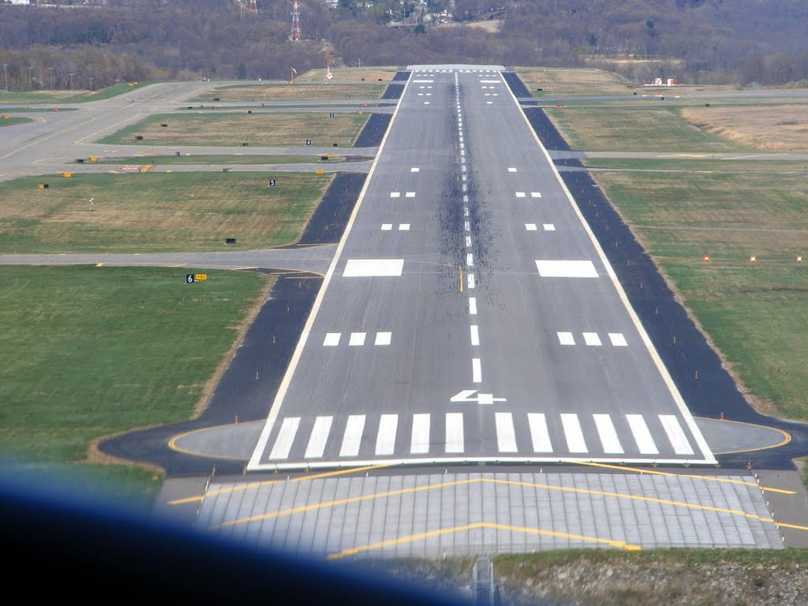
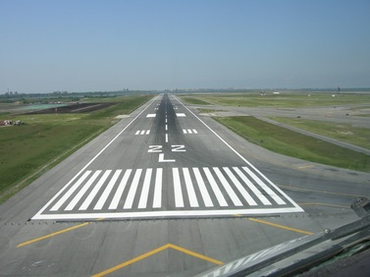

http://www.jfwhite.com/ad410640-d71e-46ec-8f6f-b36cbab689f2/projects-heavy-civil-detail.htm
http://www.northbaybusinessjournal.com/99968/santa-rosa-airport-gets-final-grant-for-airport-expansion/
http://www.randpeckaviationphotography.com/places--history.html
http://www.panoramio.com/photo/35046182
Then hand out the attached Runway Map for JFK Airport in New York City. Ask students to work together to make as many observations about the runway numbers as possible. In particular, ask them to try to determine why the same runway would have two different numbers. On the basic level, all students should realize that L and R stand for Left and Right. Some will also take it a step further and recognize that parallel runways have the same runway numbers and are just differentiated by the Left and Right classifications.

Differentiated Instruction (For Learners Needing More Help)
Some students are going to need extra prompting to look at the numbers at either end of the runway to see if there is a relationship. You might want to write the numbers on the board for them. Writing the larger number first will also help students to think of finding the difference.
33 15
22 4
27 9
32 14

Whether students recognize it on their own or are prompted, they should all see that the numbers on either end of the same runway differ by exactly 18. While 18 isn’t a significant number in the world of geometry, 180 certainly is. Some students will remember that sum of the angles in a triangle is 180°. While this is obviously true, it is not relevant here. What they should also remember is that a circle is 360° and so, 180° represents the amount of degrees in half the circle.

Teaching Strategies

Begin by quickly reviewing the different types of angles—acute, right, obtuse, straight, and reflex. They should remember the first three from earlier grades, but might not be familiar with last two, particularly reflex. The following website provides a nice visual of the reflex angle: http://www.mathsisfun.com/angles.html. Highlight down to the section called “Be careful what you measure”. This will be a nice lead-in to the first activity. Note: do not show students further than that section. At this point they do not need to think about positive and negative angles.

Activity 1.3.1a, Examining Angles in Runways will build on the runway problem to explore how the runway numbers are actually determined. The objective of this activity is for students to (a) recognize that rotations can be either clockwise or counterclockwise; and (b) that two rays with a common endpoint define an angle.

Show students the following diagram of a runway that is yet to be numbered. Now draw in a vertical line to represent due North and explain that we are the pilot flying in to land the plane from the direction shown by the plane.
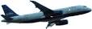
N
N

Ask students if they see any angles formed by the segment showing North and the runway. Explain that for runway numbering, we want to envision the segment containing North rotating clockwise and it is that angle of rotation that is going to lead to the runway number. Another way to think about it is to find the angle formed if the North segment was a ray and the runway was another ray.

N

Let us suppose the angle formed is 70°. You would drop the ones digit and the runway would be 7. Similarly, if the angle was 68°, you would round to 70 and again, the runway would by numbered 7.

Now if a plane is coming from the opposite direction, we again would need to look at the clockwise rotation from point N to the new heading:

N

Now the angle is 250° so the runway in that direction would be numbered 25.

Now hand out Activity sheet 1.3.1a and, as a class, go over the instructions. It instructs them to first:

Look at Runway B. Use your ruler to draw a line segment that is parallel to the North-South line and intersects the runway. Try to be as precise as possible. Have a conversation with the class about how best to do this. Some might suggest using rulers; possibly measuring distances away from the North-South line.
Now place a point on this segment that is on the North side of the runway and label this point P. Now place a point where the segment and the runway intersect and label this point Q. Finally, place a point, R, on the runway past the line segment. This is your angle PQR.

It should look like this:
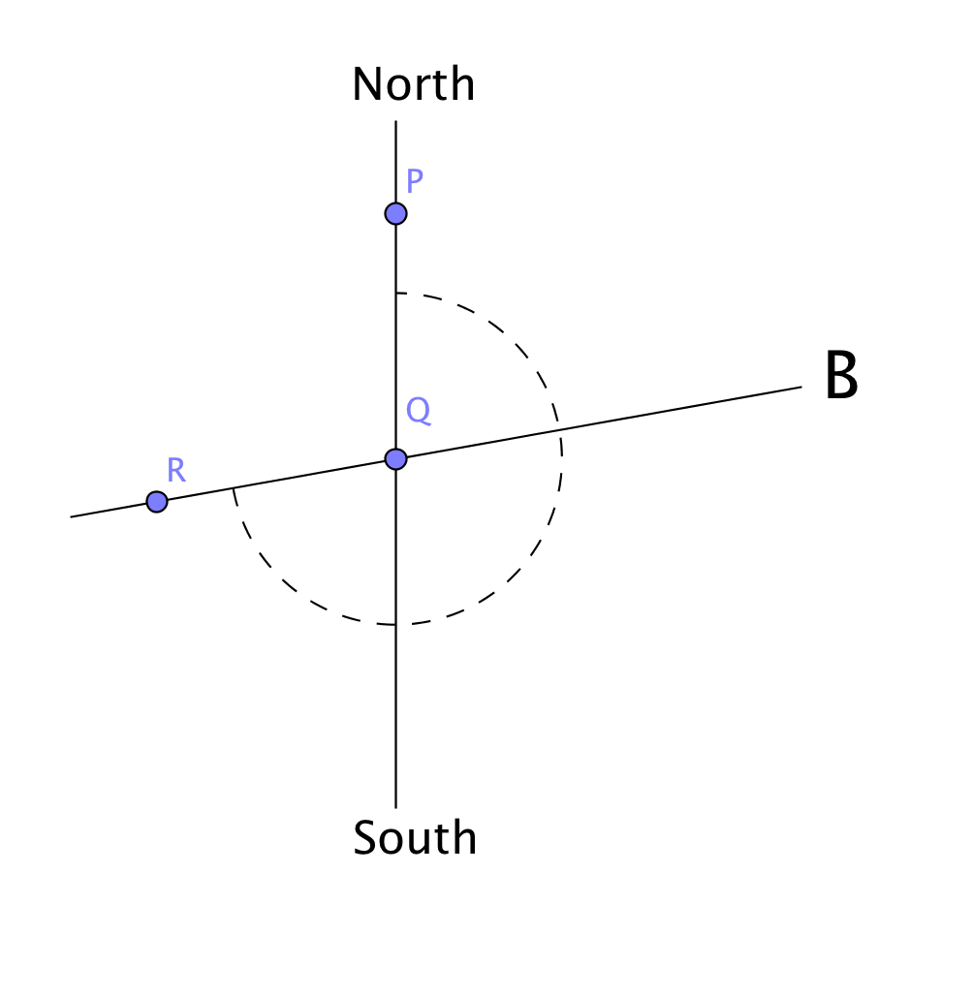
Reinforce that this creates two angles, an acute angle and a reflex angle. Just like before, we want the clockwise rotation from P to R, in this case the reflex angle. Have students think about a method we can use for measuring reflex angles with the protractor. Help them to see that we can measure the obtuse angle formed by the line segment and point R and add 180° to that
Differentiated Instruction (For Learners Needing More Help)
You may want to give some students the method for measuring reflex angles right off the bat and not have them trying to determine it. This may lead to frustration.

Students should get a value very near 260°. Note: there will be some error due to the fact that the line segment students drew will not be perfect. Explain that, like earlier examples, this would equate to a runway number of 26.
Now, have students work in small groups to find the runway numbers for the other three runways.
At this point, you can choose to move to activity 1.3.2 or you can use the next two activities, 1.3.1b Bradley Airport Runways and 1.3.1c JFK Airport Runways either as reinforcement, homework, or challenge. You will notice that the level of difficulty goes up from activity a to b to c.
Differentiated Instruction (For Advanced Learners)
In Activity 1.3.1c, see if students realize that we don’t need to calculate each runway. There are four sets of runways that are parallel. They have the same runway number, just an L or R designation (A&K., D&E, F&J, and B&C)

When going over the answers to Activity 1.3.1c, remind them that sets of runways were parallel and therefore should have same number. For instance, B and C should both be number 22. However, B will be 22L and C will be 22R.

Journal Entry: Why do the numbers at either end of a runway differ by 18? Look for students to recognize that the numbers represent increments of 10° and that two opposite rays form a straight angle measuring 180°.

At the end of the first day you may give Exit Slip 1.3.1, which asks students to measure an obtuse angle and the reflex angle associated with it.

Activity 1.3.2, Measuring Angles in Geogebra involves students exploring angle-measuring conventions in Geogebra. They will construct an angle and, similar to the overview, will measure it two different ways. They will be shown that Geogebra measures the angle determined in a counter-clockwise manner. So, selecting points in one order will give the measure of the angle and in the reverse order will give the reflex angle associated with it. They will also experience that the angle and its reflex angle have a sum of 360°.

Differentiated Instruction (For Students who are Less Tech-Savvy)
As with all software packages, Geogebra has its quirks. Some students are going to need individual help to complete the task.

The next activity in this investigation, Activity 1.3.3 Slope and Perpendicular Lines has students applying the slope criteria for perpendicular lines, which was introduced in the CT Core Algebra 1 course. They will create perpendicular lines using Geogebra and then find the product of their slopes. Geogebra will allow them to dynamically examine how moving the lines around produces different slopes, but the product always remains –1.

Activity 1.3.4 Rotations in the Coordinate plane, introduces students to mapping rules for rotations of 90°, 180°, and 270° (counterclockwise) about the origin.

At the end of the second day you may give Exit Slip 1.2.2, which asks students to rotate a polygon 90°.

Closure Notes

This investigation introduces students to clockwise and counterclockwise rotations and explores the concept of angles. Students need to understand that an angle is formed by two rays with a common endpoint and that any such formation creates two angles, an angle less than or equal to 180° and one that is greater than 180° and less than 360°. Students also need to understand how to apply the slope criteria for perpendicular lines and find the image of a figure in the coordinate plane under rotations about the origin that are multiples of 90°

Vocabulary

angle
clockwise
counterclockwise
perpendicular
rotation
side (of angle)

Postulates and Theorems

Perpendicular Lines Slope Theorem: If the slopes of two lines are opposite reciprocals, then the lines are perpendicular. (from Algebra 1)

Resources and Materials

Web sites for runway pictures and diagrams:
http://www.jfwhite.com/ad410640-d71e-46ec-8f6f-b36cbab689f2/projects-heavy-civil-detail.htm
http://www.northbaybusinessjournal.com/99968/santa-rosa-airport-gets-final-grant-for-airport-expansion/
http://www.randpeckaviationphotography.com/places--history.html
http://www.panoramio.com/photo/35046182
www.tuningpp.com
https://www.airnav.com/airport/KDXR
http://www.airnav.com/airport/KBDL

Activities:
Activity 1.3.1a, 1.3.1b, and 1.3.1c Examining Angles in Runways
Activity 1.3.2 Measuring Angles in Geogebra
Activity 1.3.3 Slope and Perpendicular Lines
Activity 1.3.4 Rotations in the Coordinate Plane

Protractors & graph paper for Activity 1.3.1a, b, c
Geogebra for Activity 1.3.2, 1.3.3, 1.3.4

Danbury Airport Runway Map (Activity 1.3.1a)
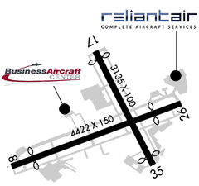

https://www.airnav.com/airport/KDXR

Bradley Airport Runway Map (Activity 1.3.1b)
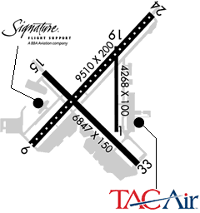
https://www.airnav.com/airport/KBDL
JFK Airport Runway Map (Activity 1.3.1c)

