Activity 2.2.1 SAS Congruence

In this activity you will discover and prove our first theorem about congruent triangles.
1. Included angles. For each pair of sides in ∆XYZ, name the included angle.

Sides: $\overline{XY}$ and $\overline{YZ}$ Included Angle: $∠ ___________$
Sides: $\overline{XY}$ and $\overline{ZX}$ Included Angle: $∠ ___________$
Sides: $\overline{ZX}$ and $\overline{YZ}$ Included Angle: $∠ ___________$

2. Experiment. Work with one other student. You will each draw two triangles using a ruler and protractor.

a. Agree upon the measure of two sides of the triangle and the included angle.

Our two sides measure ______________ and ______________.
Our included angle measures _______________.

b. Now draw your triangles. Cut one triangle out and place it on the other. What do you notice?

c. Formulate a conjecture: If two sides and the included angle of one triangle are congruent to two sides and the included angle of another triangle then ____________________________________________.

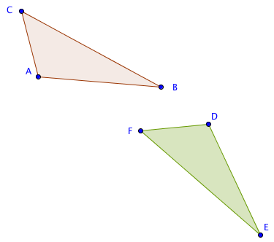
3. Proving the SAS Congruence Theorem. Study this proof and fill in the blanks.
Given ∆ABC and ∆DEF with
AB = DE,
AC = DF, and
m$∠$BAC = m$∠$EDF

Prove ∆ABC$≅$∆DEF.

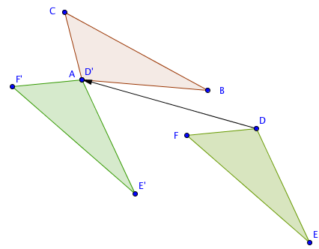
Step 1. If A and D do not coincide then translate ∆DEF by the vector from D to A.

Now D’ is the same point as _______.

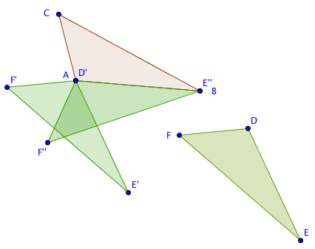
Step 2. If $\overline{AB}$ and $\overline{D’E’}$ do not coincide then rotate ∆D’E’F’ about point A through $∠$E’AB

Step 3. $\overline{D’’E’’}$ will now coincide with $\overline{AB}$ since we were given that AB = _______.

Step 4. If F’’ is on the opposite side of $\overset{⃡}{AB}$ from C, reflect ∆D’’E’’F’’ over $\overset{⃡}{AB}$.
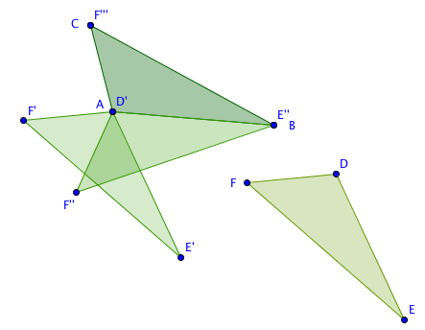
D’’ is the same as which point? _____

Step 5. $∠$E’’’D’’’F’’’ will now coincide with $∠$BAC since we were given m$∠$BAC = m$∠$EDF, and
$\overline{D’’’F’’’}$ will coincide with $\overline{AC}$ since we were given AC = DF.

Step 6. Therefore F’’’ coincides with C and E’’’ coincides with B.

How many lines can be drawn from point B to point C? ___________

Explain why $\overline{E’’F’’’}$ must coincide with $\overline{BE}$:

________________________________________________________________________

Step 7. Since ∆ABC is the image of ∆DEF under an isometry, ∆ABC$≅$∆DEF.

4. Now state the theorem you have just proved. We will call this the SAS Congruence Theorem.

If ___________________________________________________________________________,

then ________________________________________________________________.

5. What properties of transformations were used in the proof?

6. Do you think this proof would work if the angle were not included between the two sides? Explain your thinking.

