Voices Forum
2022
Back to Basics

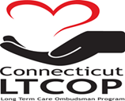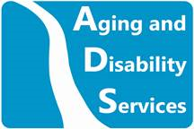


Photographs and/or video will be taken at today's event

By taking part in this event, you grant the rights to use the images resulting from the photography/video filming for publicity or other purposes. This might include (but is not limited to), the right to use them in printed and online publicity and press releases.

If you do not wish to be photographed, please inform an event organizer.

Back to the BASICS
September16,2022
Agenda

Welcome
Mairead Painter - State Long Term Care Ombudsman

Opening Remarks
Amy Porter - Commissioner of the Department of Aging and Disability Services

Presentation and Training – Care Planning Basics
Lindsay Jesshop – Regional Long term Care Ombudsman

Award Presentations
Carol Rosenwald Spirit of Advocacy Award

Brian Capshaw Rock Star Award

Legislative Update
David Peck – Statewide Coalition of Presidents of Resident Councils; President

Center for Medicare Advocacy - Know Your Medicare Rights
Judy Stein –Center for Medicare Advocacy; Executive Director/Attorney

Resident Council Meeting Basics
Statewide Coalition of Presidents of Resident Councils

Lunch

Open Mic & Panel Discussion
Patty Bausch - Statewide Coalition of Presidents of Resident Councils, Vice President
William Gui Woolston - Connecticut Medicaid Director, DSS
Nicole Godburn - Fiscal Manager, Office of Reimbursement and CON, DSS
Kim Hriceniak R.N. - Public Health Services Manager, DPH
Kate McEvoy, JD - Milbank Memorial Fund Program Officer

Closing Remarks
Mairead Painter - State Long Term Care Ombudsman

Carol Rosenwald Spirit of Advocacy Award

“You Must Hold onto Your Ideals and Always Have the Courage to Speak Your Mind” ~ Carol Rosenwald

History of the VOICES Forum

In September of 1996, nursing home resident and activist Carol Rosenwald, with assistance from the Ombudsman Program, began organizing residents across the state to advocate for improvements in the long-term care system. Carol envisioned a time when the “VOICES” of nursing home residents could be heard “beyond the walls” of their facilities. She became the founder of the Statewide Coalition of Resident Councils and the driving force behind the first “VOICES” Forum in 1997. As a large group of voting constituents, residents were able to speak directly with political leaders and public officials about important issues affecting their quality of life.

VOICES 2019 marks the 26th anniversary of Carol’s vision and of this historic event. Our heartfelt thanks to the many courageous residents who have attended VOICES over the years and to all of you attending today who inspire systems change in long term care. You have our deepest admiration and respect.

~The Long-Term Care Ombudsman Program

This year we are pleased to award the
Carol Rosenwald Spirit of Advocacy Award
to
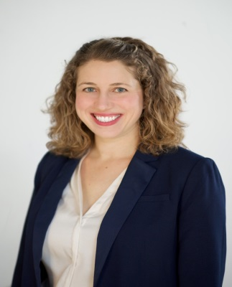

Anna Doroghazi
Associate State Director
Advocacy and Outreach AARP Connecticut

Anna Doroghazi is the Associate State Director for Advocacy and Outreach at AARP Connecticut. In that role, she advocates for policies and programs that support family caregivers, improve access to long-term services and supports, create more livable communities, and help people choose how they live as they age. Anna came to AARP Connecticut from Albany, where she worked on nonprofit policy issues for the Governor’s Office and the New York State Division of the Budget. Prior to her work in New York, Anna was the Director of Public Policy and Communication for the Connecticut Alliance to End Sexual Violence. She has a Master’s Degree from the London School of Economics.

Brian Capshaw Rock Star Award

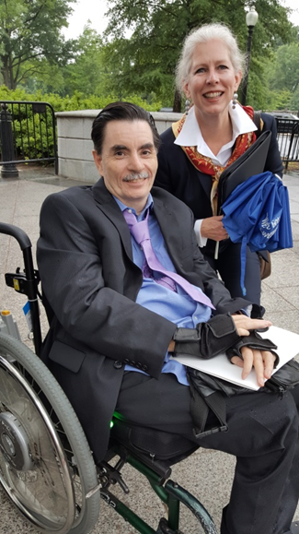

The Coalition of Presidents of Resident Councils and the Long-Term Care Ombudsman Program are pleased to announce the Brian Capshaw annually award recipient. Brian is remembered for his incredible advocacy both in Connecticut and at the national level. In 2012, Brian participated in the Consumer Voice Conference in Washington, DC. He represented Connecticut nursing home residents with a strong voice and with the incredible advocacy that only one who has “walked the walk” can bring to the conversation. He was the resident representative on the Long-Term Care Advisory Council, he testified at countless hearings, and he went door to door at the capitol talking with legislators about all the issues so important to quality care and services for nursing home residents: improved staffing levels, video monitoring, personal needs allowance, to name just a few. Brian also worked on national advocacy: he was appointed to be the Chair of the Leadership Council of the Consumer Voice; he was interviewed numerous times by the national media and participated in a wide variety of state and national workgroups. Brian was invited to the White House to participate in the 2015 White House Conference on Aging.
Brian loved sports, his family and friends, getting into his van to meet friends for concerts and various activities. He thoroughly enjoyed his rock music! Brian, in every fashion, was an inspiration and a joy to all who knew and admired him. We miss him dearly.

This year we are pleased to award the
4th annual Brian Capshaw Rock Star Award
to
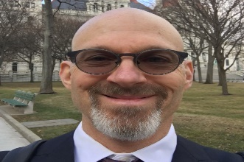

Richard Mollot
Executive Director
Long Term Care Community Coalition

Richard has been a national leader dedicated to improving quality of care, quality of life, and dignity for older adults and disabled people in nursing homes, assisted living, and other residential settings.
He has brought a national focus on systemic advocacy, researching national and state policies, laws, and regulations to identify relevant issues and develop meaningful recommendations to improve quality, efficiency, and accountability. In addition to providing a foundation for advocacy, LTCCC uses this research and the resulting recommendations to educate policymakers, consumers, and the general public. Consumer, family, and LTC ombudsman empowerment are fundamental to our mission.
Although LTCCC’s work is grounded in its organization as a New York State based coalition of consumer, community, civic, and professional organizations, bringing together these different stakeholders to identify and address the systemic issues that affect quality of care and dignity in long-term care, their reach has grown and supported change in states across the country.
For that reason, the Connecticut Coalition of Presidents of Resident Councils has chosen him to receive this year’s Brian Capshaw Rock Star Award.

E-Board 2022 CT Legislative Session End Executive Update

David Peck
President of the Statewide Coalition of Presidents of Resident Councils

2022 CT Legislative Session Selected Key Bills Passed

HB 5313 - Temporary Nursing Services Agencies, Reporting of Involuntary Transfers and Discharges from Nursing Homes and Residential Care Homes, Elder Abuse Training, Legal Rights of Long-Term Care Applicants and A Study of Managed Residential Community Issues, Aging, Public Act 22-57

HB 5485 - Various Revisions to Public Health Statutes, PH, Public Act 22-92 (includes pain management and oral hygiene new required training)
HB 5500 - DPH’s Recommendations Re: Various Revisions to the Public Health Statutes, PH, Public Act 22-58

HB 5506 - Act Adjusting the State Budget for the Biennium Ending June 30, 2023, Concerning Provisions Related to Revenue, School Construction and Other Items to Implement the State Budget and Authorizing and Adjusting Bonds of the State, Emergency Certification, Public Act 22-118 (Community Ombudsman)

SB 9 - Additional Adjustments to the State Budget for Biennium Ending June 30, 2023, A Community Ombudsman Program, Certain Municipal-Related Provisions, School Building Projects Grants, and High Deductible Health Plans, APP, Public Act 22-146 (see section 7)

SB 173 - Study of Cost-Feasibility of Permitting Community Spouse of Institutionalized Medicaid Recipient to Retain Maximum Amount of Allowable Assets, Aging, (see section 237 also Community Spouse Protected Amount/HB 5506 Budget Bill Passed), Public Act 22-121

SB 286 - Elder Abuse Reporting Deadlines, Temporary Family Assistance, Certificates of Need for Long-Term Care Facilities and Civil Penalties for Nursing Homes That Fail to Use Rate Increases for Employee Wage Enhancements, Public Act 22-145, (see amendment Sections 504 wage enhancement civil penalties possible and sections 505-508 CON for nursing homes)

HB 5205 - Fair Rent Commissions, HSG, Public Act 22-30 – statute expanded to require more towns above certain population level to have a Fair Rent Commission – greater opportunity for consumer protections to exorbitant rent increases and other landlord measures

SB 217 - Establish A Hate Crimes Investigative Unit Within Division of State Police and Require Development of a Reporting System, Best Practices and A Model Investigation Policy for Law Enforcement Units Regarding Hate Crimes, PA 22-9

Executive Board Members
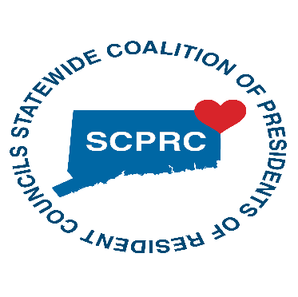

E-board Member Name Facility & Contact Information
President  David Peck | Hamden, CT 06517  203-556-1231  depeck32@gmail.com
Vice President  Patty Bausch | Newtown Rehabilitation and Health Care Center  203-997-6971  pbausch2021@icloud.com
John Balisciano Jr. | Hewitt Health and Rehab  203-924-6118  john.balisciano196593@aol.com
Susan Bilansky | Hebrew Home  860-906-4292  SBilansky45@gmail.com
Tony Gesnaldo | Glastonbury Health Care Center  860-508-1855  gesnaldoanthony@gmail.com
Martha Leland | Touchpoints of Manchester  860-432-7279  meleland5@gmail.com
Emeritus status  Jeanette Sullivan-Martinez | Pendleton Healthcare  860-333-3411  Jennie.Martinez518@gmail.com

The E-Board members are open to other resident councils reaching out to them for information.

To our Resident Advocates who selflessly volunteer their time advocating on behalf of nursing home residents.
Thank You!
Volunteer | Facility
Ann Marie Fumo | Middlesex Healthcare Center
Auline Kong | Trinity Hill
Brenda Fife | Geer Nursing and Rehabilitation Center
Colleen Mcdermott | Touchpoints of Farmington
Deb Ciofi | Bayview Health Care Center
Aishwarya Sreenivasan | West Haven Center for Nursing and Rehab
Haley B Brennan | Greentree Manor
Jennifer Glick | Chelsea Place
Joyce Werden | Norwich Sub-Acute (Norwichtown)
Karen Haabestad | Apple Rehab Mystic
Kathleen Gilbride | Bride Brook Health and Rehab
Linda Rosen | Governor’s House
Meg Dee | Parkway Pavillion
Susan Williams | Touchpoints at Chestnut

To Contact the Long-Term Care Ombudsman Program

TOLL FREE

1-866-388-1888

You can e-mail us: ltcop@ct.gov
Visit our website



portal.ct.gov/LTCOP
Visit us on Facebook



www.facebook.com/CTLTCOP

State Long Term Care Ombudsman

Mairead Painter

Regional Ombudsman

Western Region
Tasha Erskine-Jackson - North Western Region
Sylvia Crespo - South Western Region

Central Region
Brenda Texidor - Northern Central Region
Lindsay Jesshop - Middle Central Region
Daniel Beem – South Central Region

Eastern Region
TBD - North Eastern Region
Patricia Calderone – Central Eastern Region
TBD - South Eastern Region

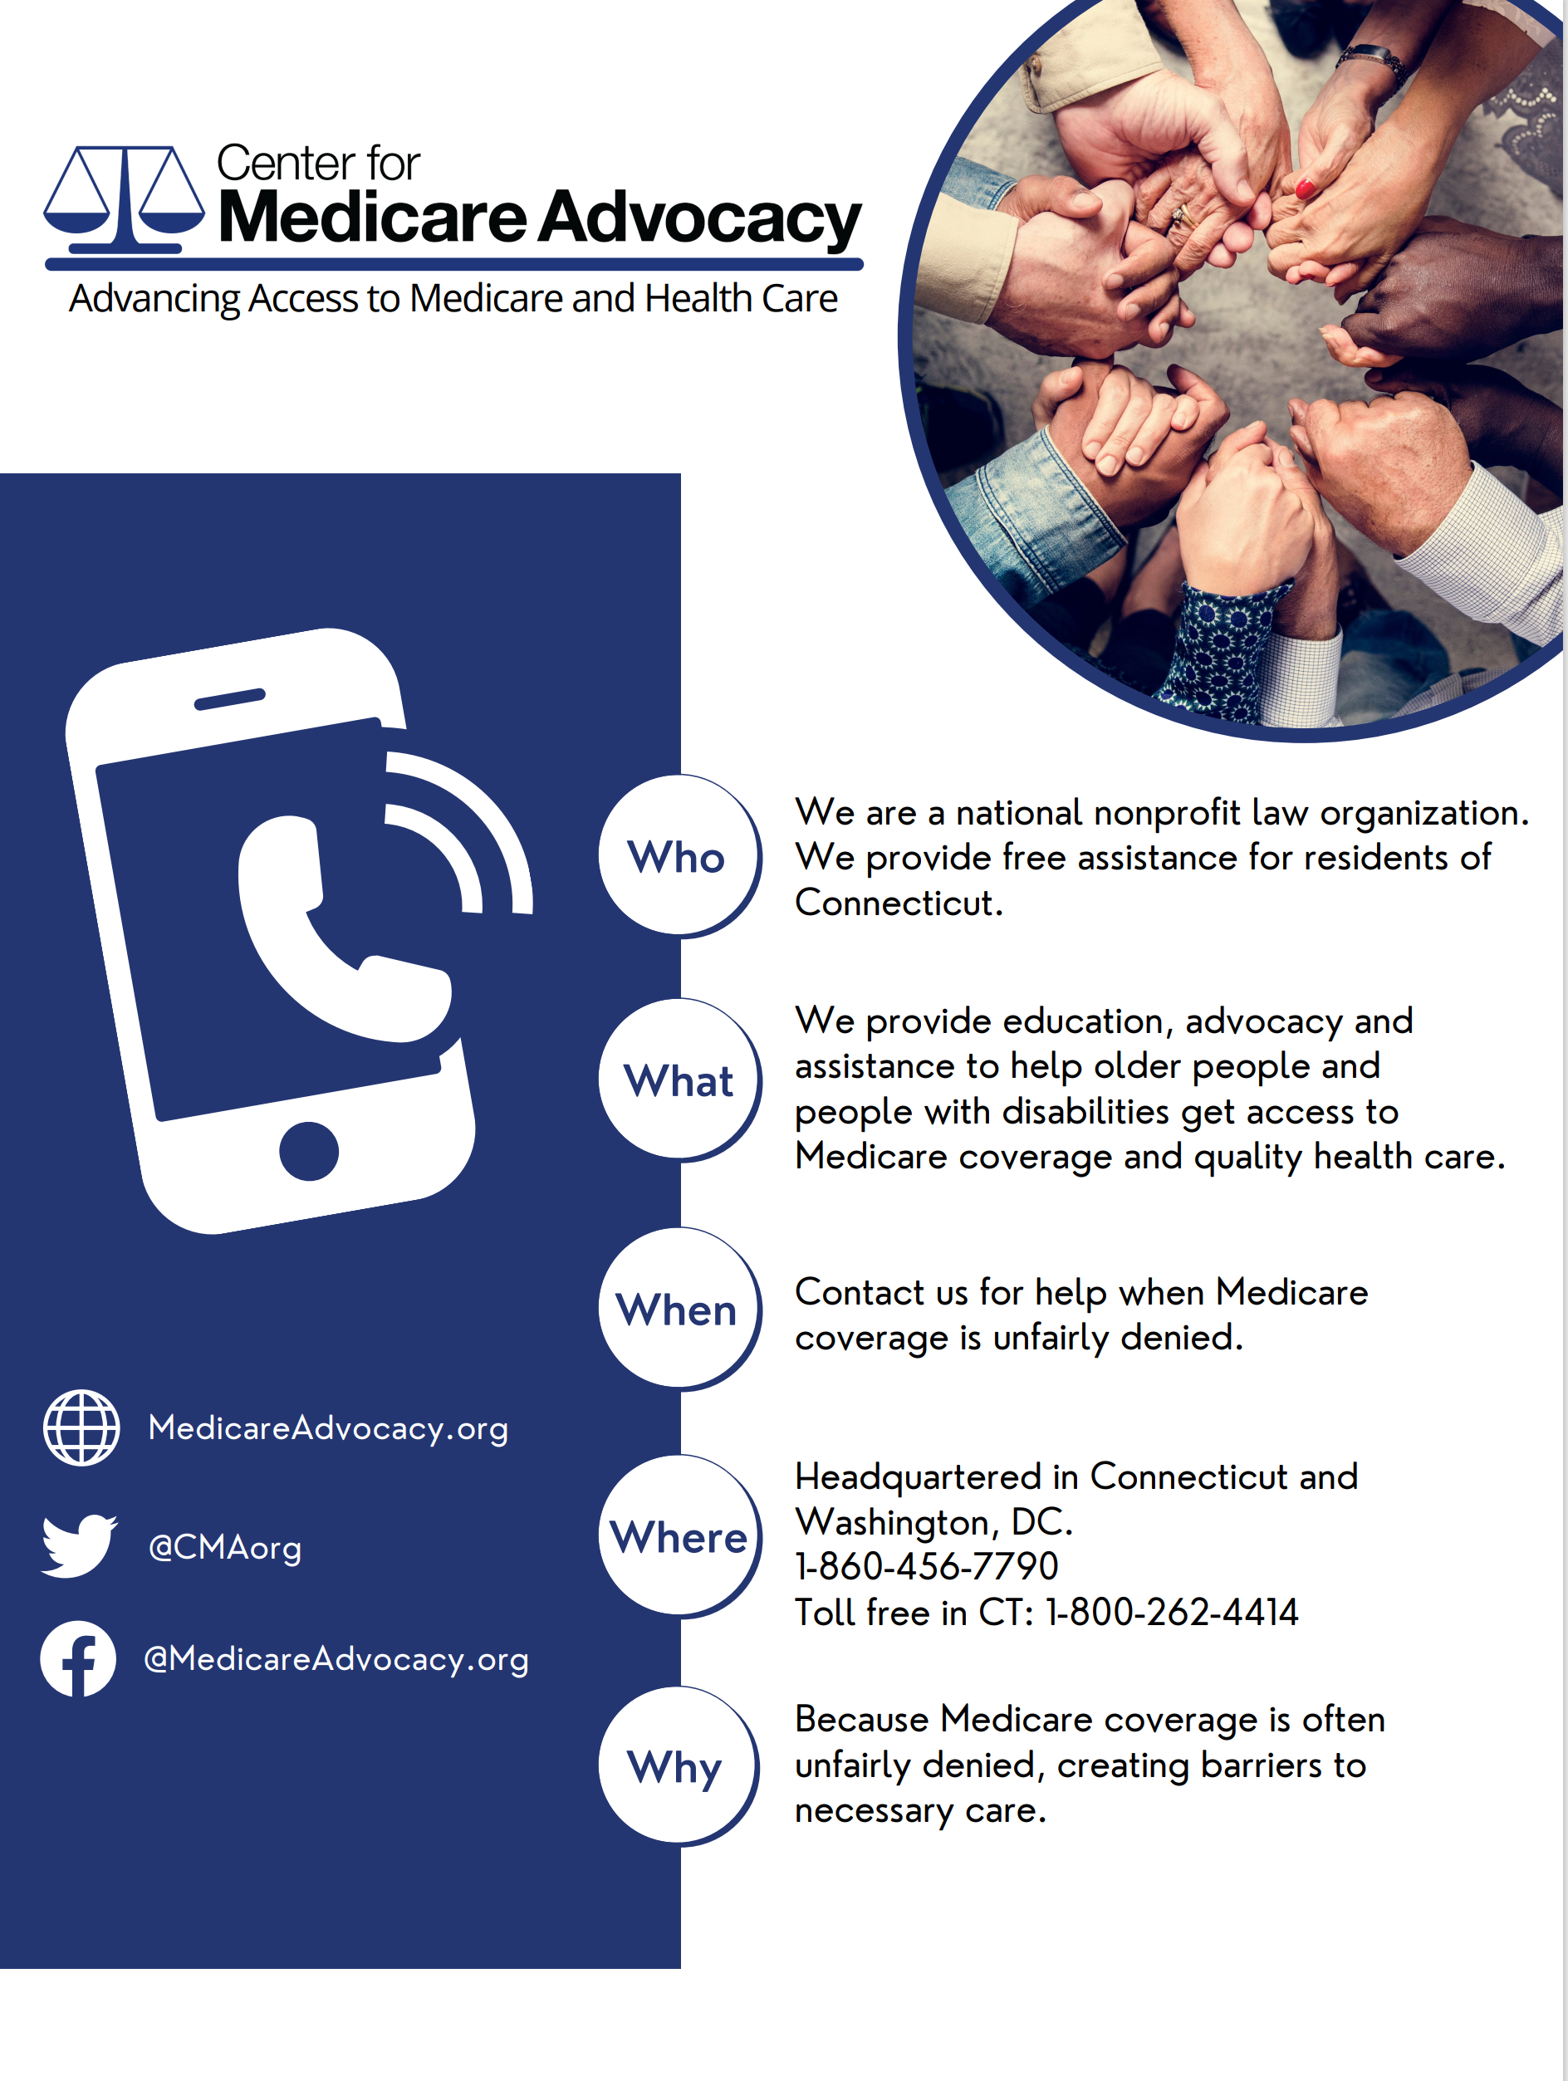
Toll Free: 1-800-262-4414

