
Statewide Family Council Meeting
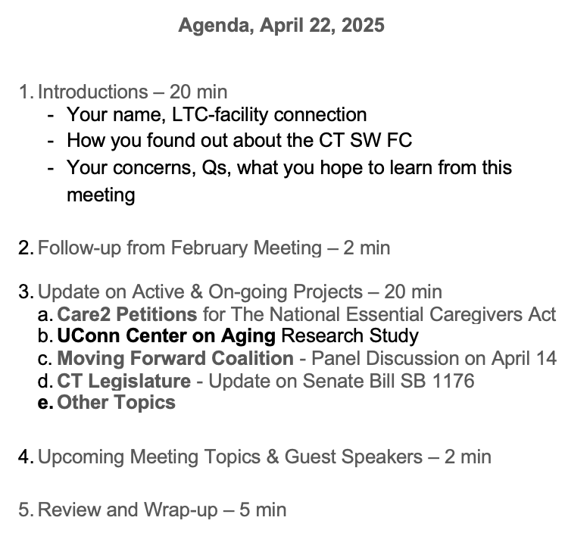
Join Zoom Meeting
https://us02web.zoom.us/j/81042484370?pwd=WmtKN3ZwSjFzNXlyczNyazc0VDJxZz09
Or Call In:
Dial: +1 929 205 6099
Meeting ID: 810 4248 4370
Passcode: 093295

For more information about the CT Statewide Family Council please visit the webpage at:
https://portal.ct.gov/LTCOP/State-Wide-Family-Council or contact us at: ctswfamilycouncil@gmail.com
8/9/23

