
Request for Proposals (RFP) For
Grants for the Control of Aquatic Invasive Species
RFP Name: 2023-2024 Grants for the Control of Aquatic Invasive Species
Issued By:
Department of Energy & Environmental Protection
October 16, 2024
The Request For Proposals is available in electronic format at CT DEEP Grants and Financial Assistance Page: https://portal.ct.gov/DEEP/Business-and-Financial-Assistance/Grants-Financial-Assistance/Grants-and-Financial-Assistance
RESPONSES MUST BE RECEIVED NO LATER THAN
December 06, 2024

The Department of Energy and Environmental Protection is an Equal Opportunity/Affirmative Action Employer.

The Department reserves the right to reject any and all submissions or cancel this procurement at any time if deemed in the best interest of the State of Connecticut (State).

TABLE OF CONTENTS
Page

Section I — GENERAL INFORMATION . . . . . . . . . . . . . 3
- Introduction . . . . . . . . . . . . . . . . . 3
- Instructions . . . . . . . . . . . . . . . . . 3

Section II — PURPOSE OF RFP AND SCOPE OF SERVICES. . . . . . . . 6
A. Department Overview . . . . . . . . . . . . . 6
B. Service Overview . . . . . . . . . . . . . . . . 6
C. Scope of Services Description. . . . . . . . . . . . 7
D. Performance Measures . . . . . . . . . . . . . . 9
E. Contract Management/Data Reporting . . . . . . . . . . 9

Section III — PROPOSAL SUBMISSION OVERVIEW . . . . . . . . . 10
A. Submission Format Information . . . . . . . . . . . . 10
- Evaluation of Proposals . . . . . . . . . . . . . . 11

Section IV — PROPOSAL SUBMISSION OUTLINE AND REQUIREMENTS . . . 14
A. Cover Sheet . . . . . . . . . . . . . . . . . 14
- Table of Contents . . . . . . . . . . . . . . . . 14
- Executive Summary . . . . . . . . . . . . . . . 14
- Main Proposal Submission Questions . . . . . . . . . . 15
- Attachments . . . . . . . . . . . . . . . . . 15
- Declaration of Confidential Information . . . . . . . . . . 15
- Conflict of Interest – Disclosure Statement . . . . . . . . . 15
- Statement of Assurances . . . . . . . . . . . . . 15

Section V — MANDATORY PROVISIONS . . . . . . . . . . . . 16
- Standard Contract Provisions . . . . . . . . . . . . 16
- Assurances . . . . . . . . . . . . . . . . . 16
- Terms and Conditions . . . . . . . . . . . . . . 17
- Rights Reserved to the State . . . . . . . . . . . . 18
- Statutory and Regulatory Compliance . . . . . . . . . . 19

Section VI — APPENDIX . . . . . . . . . . . . . . . . 22
- Abbreviations / Acronyms / Definitions . . . . . . . . . . 22
- Statement of Assurances . . . . . . . . . . . . . . 23
- Proposal Checklist . . . . . . . . . . . . . . . . 24

Attachments
A. Eligible Target Species for Control and Management Projects . . . . 24
- Connecticut Invasive Plant List . . . . . . . . . . . . 25
- Appendix A of the Connecticut Aquatic Nuisance Species Management Plan 27
D. Grants for the Control of Aquatic Invasive Species Application Form . . 31
- Grant Fund Application Instructions . . . . . . . . . . . 36

I. GENERAL INFORMATION

 A. INTRODUCTION

1. RFP Name and Number. 2024-2025 Grants for the Control of Aquatic Invasive Species RFP # DEEP12152023

2. RFP Summary. The introduction and spread of aquatic invasive species and harmful algal blooms in Connecticut pose a serious threat to the biodiversity of native aquatic ecosystems, and can affect the ecological, recreational and economic interests of the state. Nonindigenous aquatic invasive species have the potential to establish and spread rapidly due to a lack of physical and biological constraints in the habitats to which they have been introduced. With the passage of Public Act 19-190, the Connecticut General Assembly established a dedicated funding source for the “Connecticut Lakes, Rivers and Ponds Preservation Account" and made it available to DEEP for (1) restoration and rehabilitation of lakes, rivers and ponds in the state; (2) programs of DEEP for the eradication of aquatic invasive species and cyanobacteria blooms; (3) education and public outreach programs to enhance the public's understanding of the need to protect and preserve the state's lakes, rivers and ponds; (4) allocation of grants to state and municipal agencies and not-for-profit organizations to conduct research and to provide public education and public awareness to enhance understanding and management of the natural resources of the state's lakes, rivers and ponds; and (5) provision of funds for all services that support the protection and conservation of the state's lakes, rivers and ponds. This RFP provides a vehicle for state agencies, municipalities, and not-for-profit organizations to access funds from the Connecticut Lakes, Rivers and Ponds Preservation Account through a competitive grant process.

3. RFP Purpose. Provide a grant opportunity to eligible applicants to request funding toward control/management projects, research projects, and education and outreach projects related to aquatic invasive species and cyanobacteria.

 B. INSTRUCTIONS

- Official Contact. The Department has designated the individual below as the Official Contact for purposes of this RFP. The Official Contact is the only authorized contact for this procurement and, as such, handles all related communications on behalf of the Department. Proposers, prospective proposers, and other interested parties are advised that any communication with any other Department employee(s) (including appointed officials) or personnel under contract to the Department about this RFP is strictly prohibited. Proposers or prospective proposers who violate this instruction may risk disqualification from further consideration.

Name: Madeline Ortiz
Address: 79 Elm St, Hartford, CT 06106
E-Mail: DEEP.AISGrants@ct.gov

Please ensure that e-mail screening software (if used) recognizes and accepts e-mails from the Official Contact.

3. RFP Information. The RFP, amendments to the RFP, and other information associated with this procurement are available in electronic format from the Official Contact or from the Internet at the following locations:

- CT DEEP Grants and Financial Assistance Page
https://portal.ct.gov/DEEP/Business-and-Financial-Assistance/Grants-Financial-Assistance/Grants-and-Financial-Assistance

It is strongly recommended that any proposer or prospective proposer interested in this procurement check this website for any solicitation changes.

4. Procurement Schedule. See below. Dates after the due date for proposals (“Proposals Due”) are non-binding target dates only (*). The Department may amend the schedule as needed. Any change to non-target dates will be made by means of an amendment to this RFP and will be posted on the Department’s RFP Web Page.

- RFP Released: October 16, 2024
- RFP Conference: Not Applicable
- Letter of Intent Due: Not Applicable
- Deadline for Questions: November 4, 2024
- Answers Released: November 11, 2024
- Proposals Due: December 6, 2024
- (*) Proposer Selection: January 10, 2025
- (*) Start of Contract Negotiations: February 1, 2025
- (*) Start of Contract: May 1, 2025

5. Contract Awards. The award of any contract pursuant to this RFP is dependent upon the availability of funding to the Department. The Department anticipates the following:

- Number of Awards: Typically 10-20 Dependent on Available Funding and Number of Suitable Proposals
- Contract Cost: $10,000 to $75,000
- Contract Term: May 1, 2025- December 31, 2026
- Funding Source: Aquatic Invasive Species Stamp

6. Eligibility. State agencies (including State Colleges and universities), municipalities, and not-for-profit organizations are eligible to receive grants through this program. Local interest organizations such as unincorporated lake associations can develop project proposals in collaboration with municipalities or not-for-profit organizations but only the municipality in which the project water body is located, or the not-for-profit organizations can apply for funding. If the water body is located in more than one municipality, two or more municipalities may apply jointly, and a lake authority as established under sec. 7-151a of the Connecticut general Statutes may, when authorized by the legislative bodies of its respective towns, act as the agent for the member towns for the purposes of this AIS Grant program. The study or project must be conducted on an inland waterbody located in Connecticut.

Eligible project proposals include conducting projects to restore an inland water body of the state through the control and management of a population of aquatic invasive species; research projects to enhance understanding and knowledge of aquatic invasive species and/or cyanobacteria blooms (must have direct practical applicability to lakes, ponds and rivers in Connecticut); and education and outreach projects intended to enhance public awareness of aquatic invasive species and/or harmful algal blooms in Connecticut and/or promote good practices to prevent the further spread of aquatic invasive species in Connecticut’s lakes, ponds and rivers.

Eligible target aquatic invasive species for control and management related projects will be those aquatic plant species listed in Section 22a-381d of the Connecticut General Statutes (see Attachment A) and those aquatic invertebrates listed in Section 26-55-5(a) of the Regulations of Connecticut state Agencies (see Attachment A). Research and education/outreach related proposals focused on potentially invasive aquatic species identified in the Connecticut Invasive Plants Council’s Invasive Plant List (Attachment B) as well as potentially threatening species identified in Appendix A of the Connecticut Aquatic Nuisance Species Management Plan (Attachment C) may also be considered. Newly emerging aquatic invasive species may also be deemed eligible target species at the discretion of the AIS Grants Oversight Committee. Species of cyanobacteria capable of producing harmful algal blooms are eligible for all project types.

7. Minimum Qualifications of Proposers. To qualify for a contract award, a proposer must have the following minimum qualifications:

Applicants must be state agencies (including State Colleges and Universities), municipalities, or not-for-profit organizations.

8. Letter of Intent. A Letter of Intent (LOI) is not required by this RFP

9. Inquiry Procedures. All questions regarding this RFP or the Department’s procurement process must be directed, in writing, electronically, (email) to the Official Contact at DEEP.AISGrants@ct.gov before the deadline specified in the Procurement Schedule. The early submission of questions is encouraged. Questions will not be accepted or answered verbally – neither in person nor over the telephone. All questions received before the deadline(s) will be answered. However, the Department will not answer questions when the source is unknown (i.e., nuisance or anonymous questions). Questions deemed unrelated to the RFP or the procurement process will not be answered. At its discretion, the Department may or may not respond to questions received after the deadline. The Department may combine similar questions and give only one answer. All questions and answers will be compiled into a written amendment to this RFP. If any answer to any question constitutes a material change to the RFP, the question and answer will be placed at the beginning of the amendment and duly noted as such.

The agency will release the answers to questions on the date(s) established in the Procurement Schedule. The Department will publish any and all amendments to this RFP on Department’s RFP Web Page.

10. Proposal Due Date and Time. The Official Contact is the only authorized recipient of proposals submitted in response to this RFP. Proposals must be received by the Official Contact on or before December 06, 2024.

Proposals received after the due date will be ineligible and will not be evaluated. The Department will send an official letter alerting late respondents of ineligibility.

An acceptable submission must include the following:

- One (1) conforming electronic copy of the original proposal.

The proposal must be complete, properly formatted and outlined, and ready for evaluation by the Screening Committee.

Applicants must email completed application and any supporting information to DEEP.AISGrants@ct.gov

11. Multiple Proposals. The submission of multiple proposals is an option for this procurement. An applicant may submit a maximum of two (2) proposals in response to this funding opportunity.

II. PURPOSE OF RFP AND SCOPE OF SERVICES

 A. AGENCY OVERVIEW
The Connecticut Department of Energy and Environmental Protection (DEEP) is charged with conserving, improving and protecting the natural resources and the environment of the state of Connecticut as well as making cheaper, cleaner and more reliable energy available for the people and businesses of the state. The agency is also committed to playing a positive role in rebuilding Connecticut’s economy and creating jobs – and to fostering a sustainable and prosperous economic future for the state.

 B. SERVICE OVERVIEW
The Aquatic Invasive Species Grant Program (AIS Grant) was made possible in 2019 when the Connecticut General Assembly established an Aquatic Invasive Species Stamp fee (Public Act 19-190) applied to all registered boats using Connecticut waters, to provide a dedicated funding source for the “Connecticut Lakes, Rivers and Ponds Preservation Account." This account funds programs to protect the state’s lakes, ponds and rivers by addressing aquatic invasive species and cyanobacteria blooms. Municipalities, state agencies (including state colleges and universities), and not-for-profit organizations are eligible to receive grants through this program. Eligible project proposals include conducting projects to restore an inland water body of the state through the control and management of a population of aquatic invasive species; research projects to enhance understanding and knowledge of aquatic invasive species and/or cyanobacteria blooms (must have direct practical applicability to lakes, ponds and rivers in Connecticut); and education and outreach projects intended to enhance public awareness of aquatic invasive species and/or harmful algal blooms in Connecticut and/or promote good practices to prevent the further spread of aquatic invasive species in Connecticut’s lakes, ponds and rivers.

 C. SCOPE OF SERVICE DESCRIPTION

1. Organizational Expectations
Municipalities, state agencies (including state colleges and universities), and not-for-profit organizations are eligible to receive grants through this program.

2. Service Expectations
There are three types of projects that are eligible for funding:
• Control/Management projects. These projects should promote restoration of a lake, pond or river in the state through the control and management of a population or populations of aquatic invasive species and/or cyanobacteria blooms.
• Research projects. These projects should be intended to enhance understanding and knowledge of aquatic invasive species and/or cyanobacteria blooms, and have direct practical applicability to lakes, ponds and rivers in Connecticut.
• Education and outreach. These projects should enhance public awareness of aquatic invasive species and/or harmful algal blooms in Connecticut and/or promote good practices to prevent the further spread of aquatic invasive species in Connecticut’s lakes, ponds and rivers.

Additional considerations: In order to obtain the most benefit to the state, factors to be considered include (but are not limited to):
• For control/management projects, the degree of public access at the target waterbody, the ecological importance and physical characteristics of the waterbody, and the age and extent of the infestation.
• For research projects, the need for the research and its degree of applicability to Connecticut’s lakes, ponds and rivers.
• For education/outreach projects, the size and relevancy of the target audience, the need for the proposed education/outreach project, and the applicability of the media used to reach the target audience.
• Eligible target aquatic invasive species for control and management related projects will be those aquatic plant species listed in Section 22a-381d of the Connecticut General Statutes (see Attachment A) and those aquatic invertebrates listed in Section 26-55-5(a) of the Regulations of Connecticut state Agencies (see Attachment A). Research and education/outreach related proposals focused on potentially invasive aquatic species identified in the Connecticut Invasive Plants Council’s Invasive Plant List (Attachment B) as well as potentially threatening species identified in Appendix A of the Connecticut Aquatic Nuisance Species Management Plan (Attachment C) may also be considered. Species of cyanobacteria capable of producing harmful algal blooms are eligible for all project types.
• NOT eligible for funding are proposals targeting native species, or for control and management of invasive species not present prior to October 16, 2024 in the study or project waterbody or waterbodies.
• Detailed review criteria that will be used by the AIS Grants Oversight Committee during the selection process can be found on page 10 of this document.
• Grant-funded activities must occur within the period outlined in the project contract. Activities performed prior to grant contract execution will not be eligible for funding.

Below are a few examples of eligible, eligible but not high priority, and ineligible projects (reasoning in parenthesis following each example):
• Eligible projects-
o Herbicide treatment to eradicate Egeria (Egeria densa) infestation in a lake with a state boat launch. (invasive species, full public access, limited populations in the CT). See additional information on special requirements for applications of chemical herbicide treatment in Section V.
o Eradication of water chestnut (Trapa natans) by dredging and hand pulling from a town-owned pond open to the public. (invasive species, publicly accessible, newer infestation, recently arrived with limited populations in the state)
o Signage at project site and targeted social media advertisements designed to inform the public about the dangers of spreading hydrilla (Hydrilla verticillata) at boat launches along the Connecticut River (invasive species, publicly accessible, newer infestation, recently arrived with limited populations in the state)
• Eligible, but lower priority projects-
o Annual use of a mechanical harvester to clear crew team boat lanes of Eurasian water milfoil (Myriophyllum spicatum) in a lake with limited public access. (little to no general public benefit since threat to other waters is minimal; species widely distributed in state).
o Diagnostic feasibility study for zebra mussels in East Twin Lake (eligible species, but study is of limited benefit, no viable control options currently exist and the population has existed in the water body for over 15 years with limited impact to the system and no apparent impact on use).
o Educational brochure on watercress (Nasturtium officinale) to be distributed at lake and pond boat launch kiosks. (eligible species, but inappropriate target audience as this species is typically not spread by boaters and generally does not cause issues in lakes and ponds)
• Ineligible projects-
o Herbicide treatment of unusually dense growths of common bladderwort (Utricularia vulgaris) and Eurasian Watermilfoil (Myriophyllum spicatum) on a lake with a state boat launch. (part of proposal geared toward controlling a native species).
o Mechanical removal of common reed (Phragmites australis) along the edge of a lake (species not listed in Attachment A are ineligible for control and management projects).

3. Budget Expectations
The maximum grant award is $75,000 and the lower limit is $10,000. Requests for larger grants may be considered, but only for exceptional and well-justified proposals. Matching funds are required and must equal or exceed 25% of the total project cost. Indirect costs are not eligible for funding through the grant, but may be used as part of applicant’s match. Proposed projects should be completed within approximately eighteen months from the contract execution date. All seasonal constraints that may prolong the project duration must be specifically discussed in the proposal. Applicants may request an extension of the executed contract if deemed necessary. Such request shall be in writing and shall be submitted to the AIS Grants Oversight Committee at least sixty (60) days prior to the contract expiration. Such request shall describe the work done to date, what work still needs to be completed, and the reason for such extension. It shall be the AIS Grants Oversight Committee’s sole discretion to grant or deny such request.

 D. PERFORMANCE MEASURES

The following performance metrics highlight key priorities that will be analyzed with providers/vendors collaboratively during the life of the contract. This is not an exhaustive list, but rather an indication of significant performance metrics of interest to The Agency. The Agency looks forward to working with providers/vendors to define additional important performance metrics.

At project completion, the awardee must submit a final report. This report must include a detailed financial summary and project outcomes. This financial summary must show full project costs and clearly identify direct grant costs as well as matching and in-kind costs. For control and management projects, the final report should include a description of any treatments or management activities, maps of the areas impacted, as well as the results of any follow-up surveys. As post-treatment monitoring is an important aspect of invasive species control and management, please ensure that these reports are provided to DEEP. They will be useful in determining which actions are most effective, and just as important, identify those actions that are not successful. For research studies, the final report should include a detailed summary of the project methodology and results as well a discussion on any findings and/or management implications that arise out of the study. For education/outreach projects, the final report should include a description of any project activities as well as some quantification on the degree to which the project reached its target audience.

 E. CONTRACT MANAGEMENT/DATA REPORTING

As part of the State’s commitment to becoming more outcomes-oriented, DEEP, seeks to actively and regularly collaborate with providers/vendors to enhance contract management, improve results, and adjust service delivery and policy based on learning what works. Reliable and relevant data is necessary to ensure compliance, inform trends to be monitored, evaluate results and performance, and drive service improvements. As such, DEEP reserves the right to request/collect other key data and metrics from providers/vendors.

III. PROPOSAL SUBMISSION OVERVIEW

 A. SUBMISSION FORMAT INFORMATION

1. Required Outline. All proposals must follow the required outline presented in Section IV – Proposal Outline. Proposals that fail to follow the required outline will be deemed non-responsive and not evaluated.

2. Cover Sheet. The Cover Sheet is Page 1 of the proposal.

The proposer must develop a Cover Sheet that includes the information below. Legal Name is defined as the name of the provider, vendor, CT State agency, or municipality submitting the proposal. Contact Person is defined as the individual who can provide additional information about the proposal or who has immediate responsibility for the proposal. Authorized Official is defined as the individual empowered to submit a binding offer on behalf of the proposer to provide services in accordance with the terms and provisions described in this RFP and any amendments or attachments hereto.

- RFP Name or Number:
- Legal Name:
- FEIN:
- Street Address:
- Town/City/State/Zip:
- Contact Person:
- Title:
- Phone Number:
- E-Mail Address:
- Authorized Official:
- Title:
- Signature:

3. Table of Contents. All proposals must include a Table of Contents that conforms with the required proposal outline.

4. Executive Summary. Proposals must include a high-level summary, not exceeding 1 page, of the main proposal and cost proposal. The summary must also include the organization’s eligibility and qualifications to respond to this RFP.

5. Attachments. Attachments other than the required Appendices or Forms identified in the RFP are not permitted and will not be evaluated. Further, the required Appendices or Forms must not be altered or used to extend, enhance, or replace any component required by this RFP. Failure to abide by these instructions will result in disqualification.

6. Style Requirements. THIS IS AN ELECTRONIC SUBMISSION.

Submitted proposals must conform to the following specifications:

- Paper Size: None specified
- Page Limit: None specified
- Font Size: None specified
- Font Type: None specified
- Margins: None specified
- Line Spacing: None specified

7. Pagination. The proposer’s name must be displayed in the header of each page. All pages, including the required Appendices and Forms, must be numbered in the footer.

- Declaration of Confidential Information. Proposers are advised that all materials associated with this procurement are subject to the terms of the Freedom of Information Act (FOIA), the Privacy Act, and all rules, regulations and interpretations resulting from them. If a proposer deems that certain information required by this RFP is confidential, the proposer must label such information as CONFIDENTIAL prior to submission. In a subsection of the proposal submission, the proposer must reference where the information labeled CONFIDENTIAL is located in the proposal. EXAMPLE: Section G.1.a. For each subsection so referenced, the proposer must provide a convincing explanation and rationale sufficient to justify an exemption of the information from release under the FOIA. The explanation and rationale must be stated in terms of (a) the prospective harm to the competitive position of the proposer that would result if the identified information were to be released and (b) the reasons why the information is legally exempt from release pursuant to C.G.S. § 1-210(b).

- Conflict of Interest - Disclosure Statement. Proposers must include a disclosure statement concerning any current business relationships (within the last three (3) years) that pose a conflict of interest, as defined by C.G.S. § 1-85. A conflict of interest exists when a relationship exists between the proposer and a public official (including an elected official) or State employee that may interfere with fair competition or may be adverse to the interests of the State. The existence of a conflict of interest is not, in and of itself, evidence of wrongdoing. A conflict of interest may, however, become a legal matter if a proposer tries to influence, or succeeds in influencing, the outcome of an official decision for their personal or corporate benefit. The Department will determine whether any disclosed conflict of interest poses a substantial advantage to the proposer over the competition, decreases the overall competitiveness of this procurement, or is not in the best interests of the State. In the absence of any conflict of interest, a proposer must affirm such in the disclosure statement. Example: “[name of proposer] has no current business relationship (within the last three (3) years) that poses a conflict of interest, as defined by C.G.S. § 1-85.”

 B. EVALUATION OF PROPOSALS

1. Evaluation Process. It is the intent of the Agency to conduct a comprehensive, fair, and impartial evaluation of proposals received in response to this RFP. When evaluating proposals, negotiating with successful proposers, and awarding contracts, the Department will conform with its written procedures for POS and PSA procurements (pursuant to C.G.S. § 4-217) and the State’s Code of Ethics (pursuant to C.G.S. §§ 1-84 and 1-85). Final funding allocation decisions will be determined during contract negotiation.

2. Evaluation Review Committee. DEEP will designate a Review Committee to evaluate proposals submitted in response to this RFP. The Review Committee will be composed of individuals, DEEP staff or other designees as deemed appropriate. The contents of all submitted proposals, including any confidential information, will be shared with the Review Committee. Only proposals found to be responsive (that is, complying with all instructions and requirements described herein) will be reviewed, rated, and scored. Proposals that fail to comply with all instructions will be rejected without further consideration. The Review Committee shall evaluate all proposals that meet the Minimum Submission Requirements by score and rank ordered and make recommendations for awards. The Deputy Commissioner will make the final selection. Attempts by any proposer (or representative of any proposer) to contact or influence any member of the Review Committee may result in disqualification of the proposer.

3. Minimum Submission Requirements. To be eligible for evaluation, proposals must (1) be received on or before the due date and time; (2) meet the Proposal Format requirements; (3) meet the Eligibility and Qualification requirements to respond to the procurement, (4) follow the required Proposal Outline; and (5) be complete. Proposals that fail to follow instructions or satisfy these minimum submission requirements will not be reviewed further The Agency will reject any proposal that deviates significantly from the requirements of this RFP.

4. Evaluation Criteria (and Weights). Proposals meeting the Minimum Submission Requirements will be evaluated according to the established criteria. The criteria are the objective standards that the Review Committee will use to evaluate the technical merits of the proposals. Only the criteria listed below will be used to evaluate proposals. The weights are disclosed below.
- Compliance with all eligibility requirements listed above.
- Degree of access available to the public. (5 points)
- Degree and imminence of threat posed by target species. (10 points)
- Ecological benefits of project including impacts to rare/endangered/threatened/species of concern. (10 points)
- Recreational benefits of project. (5 points)
- Expected benefits on a watershed scale or potential to coordinate efforts with other projects. (5 points)
- Cost effectiveness of project (5 points)
- Ability of applicant to implement and complete study or project in a timely fashion. (10 points)
- Project merits relative to past work in a waterbody or related grant-funded activities. (5 points)
- Amount of public use and potential for people to spread target species to other water bodies. (control projects only; 5 points)
- Effectiveness of project control measures (completeness & duration of control expected; control projects only; 10 points).
- Quality of post treatment monitoring plan (control projects only; 5 points).
- Quality of long-term management plan (control projects only; 5 points), Applications which demonstrate a commitment to continue the proposed project beyond the initial year of its implementation without additional DEEP support will be viewed more favorably. Ability of applicant to implement and complete the study or project in a timely fashion. (This includes the extent to which proposals would be completed within eighteen months from the contract execution date. It also takes past performance of the applicant into consideration if previously provided funding by DEEP or other state source).
- Project appeals to an appropriate target audience (education/outreach projects only; 10 points)
- Project designed to effectively reach target audience (education/outreach projects only; 10 points)
- Project design includes a plan or metrics to evaluate the reach of the intended message (education/outreach projects only; 5 points)
- Quality of study design and overall methodology (research projects only; 10 points)
- Study design expected to yield actionable management implications for target species (research projects only; 15 points)

5. Proposer Selection. Upon completing its evaluation of proposals, the Review Committee will submit the rankings of all proposals to the Commissioner or Agency Head. The final selection of a successful proposer is at the discretion of the Commissioner. Any proposer selected will be so notified and awarded an opportunity to negotiate a contract with the Agency. Such negotiations may, but will not automatically, result in a contract. All unsuccessful proposers will be notified by e-mail or U.S. mail, at the Agency’s discretion, about the outcome of the evaluation and proposer selection process. The Agency reserves the right to decline to award contracts for activities in which the Commissioner considers there are not adequate respondents.

6. Contract Execution. These project awards are reimbursement grants that are funded through contracts, which may include approval by the Office of the Attorney General. This means that payment for the project awarded activity will occur according to the terms of the state contract after the grant project has been completed and final outputs have been submitted and approved by DEEP. Proof that payments have been made for project expenses such as invoices and canceled checks, must be submitted before reimbursement will occur. Reimbursement can only be issued for eligible cost incurred during the grant period – no reimbursements will be issued for expenditures made before receipt of an executed contract or after the contract has expired.

IV. REQUIRED PROPOSAL SUBMISSION OUTLINE AND REQUIREMENTS

A. Cover Sheet

B. Table of Contents

C. Executive Summary

D. Main Proposal

E. Attachments (clearly referenced to summary and main proposal where applicable)

F. Declaration of Confidential Information

G. Conflict of Interest - Disclosure Statement

H. Statement of Assurances

A: Cover Sheet

The Respondent must use a Cover Sheet capturing the following information:
- RFP Name or Number:
- Legal Name:
- FEIN (not required for currently contracted providers/vendors:
- Street Address:
- Town/City/State/Zip:
- Contact Person:
- Title:
- Phone Number:
- E-Mail Address:
- Authorized Official:
- Title:
- Signature:

Legal Name is defined as the name of provider, vendor, CT State agency, or municipality submitting the proposal. Contact Person is defined as the individual who can provide additional information about the proposal or who has immediate responsibility for the proposal. Authorized Official is defined as the individual empowered to submit a binding offer on behalf of the proposer to provide services in accordance with the terms and provisions described in this RFP and any amendments or attachments hereto.

B: Table of Contents

Respondents must include a Table of Contents that lists sections and subsections with page numbers that follow the organization outline and sequence for this proposal.

C: Proposer Executive Summary

The page limitation for this section is 1 pages briefly describing how the Respondent meets the eligibility and qualification criteria outlined in the Proposal Overview and a brief overview of why the Respondent should be selected for the activities highlighted in the scope of services.

D: Main Proposal Submission Requirements To Submit a Responsive Proposal:

The Grants for the Control of Aquatic Invasive Species Application Form (Attachment D) shall serve as the body of the main proposal. Specific instructions for completing the form can be found in Attachment E.

E: Attachments

Attachments other than the required attachments identified in Attachment C are not permitted and will not be evaluated. Further, the required attachments must not be altered or used to extend, enhance, or replace any component required by this RFP. Failure to abide by these instructions may result in disqualification.

F: Declaration of Confidential Information

If a proposer deems that certain information required by this RFP is confidential, the proposer must label such information as CONFIDENTIAL prior to submission. The proposer must reference where the information labeled CONFIDENTIAL is located in the proposal. EXAMPLE: Section G.1.a. For each subsection so referenced, the proposer must provide a convincing explanation and rationale sufficient to justify an exemption of the information from release under the FOIA. The explanation and rationale must be stated in terms of (a) the prospective harm to the competitive position of the proposer that would result if the identified information were to be released and (b) the reasons why the information is legally exempt from release pursuant to C.G.S. § 1-210(b).

G: Conflict of Interest – Disclosure Statement

Proposers must include a disclosure statement concerning any current business relationships (within the last three (3) years) that pose a conflict of interest, as defined by C.G.S. § 1-85. A conflict of interest exists when a relationship exists between the proposer and a public official (including an elected official) or State employee that may interfere with fair competition or may be adverse to the interests of the State. The existence of a conflict of interest is not, in and of itself, evidence of wrongdoing. A conflict of interest may, however, become a legal matter if a proposer tries to influence, or succeeds in influencing, the outcome of an official decision for their personal or corporate benefit. In the absence of any conflict of interest, a proposer must affirm such in the disclosure statement. Example: “[name of proposer] has no current business relationship (within the last three (3) years) that poses a conflict of interest, as defined by C.G.S. § 1-85.”

H: Statement of Assurances

Place after Conflict of Interest-Disclosure Statement. Sign and return page 23 of 43.

V. MANDATORY PROVISIONS

 A. STANDARD CONTRACT PROVISIONS

Agencies can include any standard PSA contract provisions that are valuable to communicate in advance to the provider/vendor community. This may include a sample agency PSA, an agency specific PSA contract template, or a reference to the Comptroller’s Office PSA Terms and Conditions, which includes generic state contract requirements.

 B. ASSURANCES

By submitting a proposal in response to this RFP, a proposer implicitly gives the following assurances:

1. Collusion. The proposer represents and warrants that the proposer did not participate in any part of the RFP development process and had no knowledge of the specific contents of the RFP prior to its issuance. The proposer further represents and warrants that no agent, representative, or employee of the State participated directly in the preparation of the proposer’s proposal. The proposer also represents and warrants that the submitted proposal is in all respects fair and is made without collusion or fraud.

2. State Officials and Employees. The proposer certifies that no elected or appointed official or employee of the State has or will benefit financially or materially from any contract resulting from this RFP. The Department may terminate a resulting contract if it is determined that gratuities of any kind were either offered or received by any of the aforementioned officials or employees from the proposer, contractor, or its agents or employees.

3. Competitors. The proposer assures that the submitted proposal is not made in connection with any competing organization or competitor submitting a separate proposal in response to this RFP. No attempt has been made, or will be made, by the proposer to induce any other organization or competitor to submit, or not submit, a proposal for the purpose of restricting competition. The proposer further assures that the proposed costs have been arrived at independently, without consultation, communication, or agreement with any other organization or competitor for the purpose of restricting competition. Nor has the proposer knowingly disclosed the proposed costs on a prior basis, either directly or indirectly, to any other organization or competitor.

4. Validity of Proposal. The proposer certifies that the proposal represents a valid and binding offer to provide services in accordance with the terms and provisions described in this RFP and any amendments or attachments hereto. The proposal shall remain valid for a period of 180 days after the submission due date and may be extended beyond that time by mutual agreement. At its sole discretion, the Department may include the proposal, by reference or otherwise, into any contract with the successful proposer.

5. Press Releases. The proposer agrees to obtain prior written consent and approval of the Agency for press releases that relate in any manner to this RFP or any resultant contract.

 C. TERMS AND CONDITIONS

By submitting a proposal in response to this RFP, a proposer implicitly agrees to comply with the following terms and conditions:

1. Equal Opportunity and Affirmative Action. The State is an Equal Opportunity and Affirmative Action employer and does not discriminate in its hiring, employment, or business practices. The State is committed to complying with the Americans with Disabilities Act of 1990 (ADA) and does not discriminate on the basis of disability in admission to, access to, or operation of its programs, services, or activities.

2. Preparation Expenses. Neither the State nor the Agency shall assume any liability for expenses incurred by a proposer in preparing, submitting, or clarifying any proposal submitted in response to this RFP.

3. Exclusion of Taxes. The Agency is exempt from the payment of excise and sales taxes imposed by the federal government and the State. Proposers are liable for any other applicable taxes.

4. Proposed Costs. No cost submissions that are contingent upon a State action will be accepted. All proposed costs must be fixed through the entire term of the contract.

5. Changes to Proposal. No additions or changes to the original proposal will be allowed after submission. While changes are not permitted, the Agency may request and authorize proposers to submit written clarification of their proposals, in a manner or format prescribed by the Agency, and at the proposer’s expense.

6. Supplemental Information. Supplemental information will not be considered after the deadline submission of proposals, unless specifically requested by the Department. The Department may ask a proposer to give demonstrations, interviews, oral presentations or further explanations to clarify information contained in a proposal. Any such demonstration, interview, or oral presentation will be at a time selected and in a place provided by the Department. At its sole discretion, the Agency may limit the number of proposers invited to make such a demonstration, interview, or oral presentation and may limit the number of attendees per proposer.

7. Presentation of Supporting Evidence. If requested by the Agency, a proposer must be prepared to present evidence of experience, ability, data reporting capabilities, financial standing, or other information necessary to satisfactorily meet the requirements set forth or implied in this RFP. The Agency may make onsite visits to an operational facility or facilities of a proposer to evaluate further the proposer’s capability to perform the duties required by this RFP. At its discretion, the Agency may also check or contact any reference provided by the proposer.

8. RFP Is Not An Offer. Neither this RFP nor any subsequent discussions shall give rise to any commitment on the part of the State or the Agency or confer any rights on any proposer unless and until a contract is fully executed by the necessary parties. The contract document will represent the entire agreement between the proposer and the Agency and will supersede all prior negotiations, representations or agreements, alleged or made, between the parties. The State shall assume no liability for costs incurred by the proposer or for payment of services under the terms of the contract until the successful proposer is notified that the contract has been accepted and approved by the Agency and, if required, by the Attorney General’s Office.

 D. RIGHTS RESERVED TO THE STATE

By submitting a proposal in response to this RFP, a proposer implicitly accepts that the following rights are reserved to the State:

1. Timing Sequence. The timing and sequence of events associated with this RFP shall ultimately be determined by the Agency.

2. Amending or Canceling RFP. The Agency reserves the right to amend or cancel this RFP on any date and at any time, if the Agency deems it to be necessary, appropriate, or otherwise in the best interests of the State.

3. No Acceptable Proposals. In the event that no acceptable proposals are submitted in response to this RFP, the Agency may reopen the procurement process, if it is determined to be in the best interests of the State.

4. Award and Rejection of Proposals. The Agency reserves the right to award in part, to reject any and all proposals in whole or in part, for misrepresentation or if the proposal limits or modifies any of the terms, conditions, or specifications of this RFP. The Agency may waive minor technical defects, irregularities, or omissions, if in its judgment the best interests of the State will be served. The Agency reserves the right to reject the proposal of any proposer who submits a proposal after the submission date and time.

5. Sole Property of the State. All proposals submitted in response to this RFP are to be the sole property of the State. Any product, whether acceptable or unacceptable, developed under a contract awarded as a result of this RFP shall be the sole property of the State, unless stated otherwise in this RFP or subsequent contract. The right to publish, distribute, or disseminate any and all information or reports, or part thereof, shall accrue to the State without recourse.

6. Contract Negotiation. The Agency reserves the right to negotiate or contract for all or any portion of the services contained in this RFP. The Agency further reserves the right to contract with one or more proposer for such services. After reviewing the scored criteria, the Agency may seek Best and Final Offers (BFO) on cost from proposers. The Agency may set parameters on any BFOs received.

7. Clerical Errors in Award. The Agency reserves the right to correct inaccurate awards resulting from its clerical errors. This may include, in extreme circumstances, revoking the awarding of a contract already made to a proposer and subsequently awarding the contract to another proposer. Such action on the part of the State shall not constitute a breach of contract on the part of the State since the contract with the initial proposer is deemed to be void ab initio and of no effect as if no contract ever existed between the State and the proposer.

8. Key Personnel. When the Agency is the sole funder of a purchased service, the Department reserves the right to approve any additions, deletions, or changes in key personnel, with the exception of key personnel who have terminated employment. The Agency also reserves the right to approve replacements for key personnel who have terminated employment. The Agency further reserves the right to require the removal and replacement of any of the proposer’s key personnel who do not perform adequately, regardless of whether they were previously approved by the Agency.

 E. STATUTORY AND REGULATORY COMPLIANCE

By submitting a proposal in response to this RFP, the proposer implicitly agrees to comply with all applicable State and federal laws and regulations, including, but not limited to, the following:

1. Freedom of Information, C.G.S. § 1-210(b). The Freedom of Information Act (FOIA) generally requires the disclosure of documents in the possession of the State upon request of any citizen, unless the content of the document falls within certain categories of exemption, as defined by C.G.S. § 1-210(b). Proposers are generally advised not to include in their proposals any confidential information. If the proposer indicates that certain documentation, as required by this RFP, is submitted in confidence, the State will endeavor to keep said information confidential to the extent permitted by law. The State has no obligation to initiate, prosecute, or defend any legal proceeding or to seek a protective order or other similar relief to prevent disclosure of any information pursuant to a FOIA request. The proposer has the burden of establishing the availability of any FOIA exemption in any proceeding where it is an issue. While a proposer may claim an exemption to the State’s FOIA, the final administrative authority to release or exempt any or all material so identified rests with the State. In no event shall the State or any of its employees have any liability for disclosure of documents or information in the possession of the State and which the State or its employees believe(s) to be required pursuant to the FOIA or other requirements of law.

2. Contract Compliance, C.G.S. § 4a-60 and Regulations of CT State Agencies § 46a-68j-21 thru 43, inclusive. CT statutes and regulations impose certain obligations on State agencies (as well as contractors and subcontractors doing business with the State) to ensure that State agencies do not enter into contracts with organizations or businesses that discriminate against protected class persons.

3. Consulting Agreements, C.G.S. § 4a-81. Pursuant to C.G.S. §§ 4a-81 the successful contracting party shall certify that it has not entered into any consulting agreements in connection with this Contract, except for the agreements listed below. "Consulting agreement" means any written or oral agreement to retain the services, for a fee, of a consultant for the purposes of (A) providing counsel to a contractor, vendor, consultant or other entity seeking to conduct, or conducting, business with the State, (B) contacting, whether in writing or orally, any executive, judicial, or administrative office of the State, including any department, institution, bureau, board, commission, authority, official or employee for the purpose of solicitation, dispute resolution, introduction, requests for information, or (C) any other similar activity related to such contracts. "Consulting agreement" does not include any agreements entered into with a consultant who is registered under the provisions of chapter 10 of the Connecticut General Statutes as of the date such contract is executed in accordance with the provisions of section 4a-81 of the Connecticut General Statutes. Such representation shall be sworn as true to the best knowledge and belief of the person signing the resulting contract and shall be subject to the penalties of false statement.

4. Campaign Contribution Restriction, C.G.S. § 9-612. For all State contracts, defined in section 9-612 of the Connecticut General Statutes as having a value in a calendar year of $50,000 or more, or a combination or series of such agreements or contracts having a value of $100,000 or more, the authorized signatory to the resulting contract must represent that they have received the State Elections Enforcement Commission’s notice advising state contractors of state campaign contribution and solicitation prohibitions, and will inform its principals of the contents of the notice, as set forth in “Notice to Executive Branch State Contractors and Prospective State Contractors of Campaign Contribution and Solicitation Limitations.” Such notice is available at https://seec.ct.gov/Portal/data/forms/ContrForms/seec_form_11_notice_only.pdf

5. Gifts, C.G.S. § 4-252. Pursuant to section 4-252 of the Connecticut General Statutes and Acting Governor Susan Bysiewicz’s Executive Order No. 21-2, the Contractor, for itself and on behalf of all of its principals or key personnel who submitted a bid or proposal, represents:

(1) That no gifts were made by (A) the Contractor, (B) any principals and key personnel of the Contractor, who participate substantially in preparing bids, proposals or negotiating State contracts, or (C) any agent of the Contractor or principals and key personnel, who participates substantially in preparing bids, proposals or negotiating State contracts, to (i) any public official or State employee of the State agency or quasi- public agency soliciting bids or proposals for State contracts, who participates substantially in the preparation of bid solicitations or requests for proposals for State contracts or the negotiation or award of State contracts, or (ii) any public official or State employee of any other State agency, who has supervisory or appointing authority over such State agency or quasi-public agency;

(2) That no such principals and key personnel of the Contractor, or agent of the Contractor or of such principals and key personnel, knows of any action by the Contractor to circumvent such prohibition on gifts by providing for any other principals and key personnel, official, employee or agent of the Contractor to provide a gift to any such public official or State employee; and

(3) That the Contractor is submitting bids or proposals without fraud or collusion with any person.

Any bidder or proposer that does not agree to the representations required under this section shall be rejected and the State agency or quasi-public agency shall award the contract to the next highest ranked proposer or the next lowest responsible qualified bidder or seek new bids or proposals.
  - Iran Energy Investment Certification C.G.S. § 4-252(a). Pursuant to C.G.S. § 4-252(a), the successful contracting party shall certify the following: (a) that it has not made a direct investment of twenty million dollars or more in the energy sector of Iran on or after October 1, 2013, as described in Section 202 of the Comprehensive Iran Sanctions, Accountability and Divestment Act of 2010, and has not increased or renewed such investment on or after said date. (b) If the Contractor makes a good faith effort to determine whether it has made an investment described in subsection (a) of this section it shall not be subject to the penalties of false statement pursuant to section 4-252a of the Connecticut General Statutes. A "good faith effort" for purposes of this subsection includes a determination that the Contractor is not on the list of persons who engage in certain investment activities in Iran created by the Department of General Services of the State of California pursuant to Division 2, Chapter 2.7 of the California Public Contract Code. Nothing in this subsection shall be construed to impair the ability of the State agency or quasi-public agency to pursue a breach of contract action for any violation of the provisions of the resulting contract.

7. Nondiscrimination Certification, C.G.S. § 4a-60 and 4a-60a. If a bidder is awarded an opportunity to negotiate a contract, the proposer must provide the State agency with written representation in the resulting contract that certifies the bidder complies with the State's nondiscrimination agreements and warranties. This nondiscrimination certification is required for all State contracts – regardless of type, term, cost, or value. Municipalities and CT State agencies are exempt from this requirement. The authorized signatory of the contract shall demonstrate his or her understanding of this obligation by either (A) initialing the nondiscrimination affirmation provision in the body of the resulting contract, or (B) providing an affirmative response in the required online bid or response to a proposal question, if applicable, which asks if the contractor understands its obligations. If a bidder or vendor refuses to agree to this representation, such bidder or vendor shall be rejected and the State agency or quasi-public agency shall award the contract to the next highest ranked vendor or the next lowest responsible qualified bidder or seek new bids or proposals.

8. Access to Data for State Auditors. The Contractor shall provide to OPM access to any data, as defined in C.G.S. § 4e-1, concerning the resulting contract that are in the possession or control of the Contractor upon demand and shall provide the data to OPM in a format prescribed by OPM [or DEEP] and the State Auditors of Public Accounts at no additional cost.

9. Special Requirements for the control and management of invasive species using herbicides. Proposals that include work with sub-contractors to apply herbicides for invasives management must comply with the following:
  - Adhere to relevant state statutes and regulations including but not limited to: CGS §§ 22a-54 , 22a-66(l) and 22a-61, relevant sections of CGS Chapter 441, and RCSA 22a-66a.
    - Provide documentation of the sub-contractor's business registration and pesticide certification. Proposed herbicide use in or immediately adjacent to bodies of water will require aquatic permits and certifications will be required in accordance with CGS § 22a-66z.
    - Publish a notice of pesticide application in a newspaper of general circulation in each municipality in which the lake or pond is located and install signage per state pesticide regulations, requirements of CGS § 22a-66a(h) and RCSA 22-66a.

- Special Requirements for Projects Utilizing a State Boat Launch. In accordance with CGS 23-11, RCSA 23-4-1 through 23-4-4, and RCSA 26-16-1, proposals that include project activities such as aquatic herbicide application, boat launch monitors, or other commercial activities that require the use of a State Boat Launch by the contractor or subcontractor, will be required to provide a DEEP Special Use License (SUL) prior to Contract execution. Please visit Special Use License (ct.gov) for more information on Special Use Licenses and how to apply. Please contact deep.boating@ct.gov and deep.specialuse@ct.gov for questions on SUL applications. As a requirement of the SUL, the Licensee shall obtain, at its own cost and for the duration of this license, commercial general liability insurance in the amount of $1,000,000 combined single limit per occurrence for bodily injury, personal injury, and property damage. Coverage shall include 1.) Premises and Operations, 2.) Independent Contractors, 3.) Contractual Liability, and 4.) Broad Form Property Damage. If a general aggregate is used, the general aggregate limit shall apply separately to the project or the general aggregate limit shall be twice the occurrence limit. The 'State of Connecticut, DEEP' shall be named as an Additional Insured on all coverages. The coverage shall contain no special limitations on the scope of protection afforded to the State. The Licensee shall assume any and all deductibles in the described insurance policies. The Licensee's insurer shall have no right of recovery or subrogation against the State and the described insurance shall be the primary coverage. Any failure to comply with the claim reporting provisions of the policy shall not affect coverage provided to the State. The insurance policy shall not be suspended, voided, cancelled or reduced, except after 30 days prior written notice by certified mail has been given to the State

VI. APPENDIX

A. ABBREVIATIONS / ACRONYMS / DEFINITIONS

BFO Best and Final Offer
C.G.S. Connecticut General Statutes
CHRO Commission on Human Rights and Opportunity (CT)
CT Connecticut
DAS Department of Administrative Services (CT)
FOIA Freedom of Information Act (CT)
IRS Internal Revenue Service (US)
LOI Letter of Intent
OAG Office of the Attorney General
OPM Office of Policy and Management (CT)
OSC Office of the State Comptroller (CT)
PSA Personal Service Agreement
P.A. Public Act (CT)
RCSA Regulations for Connecticut State Agencies
RFP Request For Proposal
SEEC State Elections Enforcement Commission (CT)
U.S. United States

- contractor: a private provider organization, CT State agency, or municipality that enters into a POS contract with the Department as a result of this RFP.

- proposer: a private provider organization, CT State agency, or municipality that has submitted a proposal to the Agency in response to this RFP. This term may be used interchangeably with respondent throughout the RFP.

- prospective proposer: a private provider organization, CT State agency, or municipality that may submit a proposal to the Agency in response to this RFP, but has not yet done so

- subcontractor: an individual (other than an employee of the contractor) or business entity hired by a contractor to provide a specific service as part of a PSA with the Agency as a result of this RFP

B. STATEMENT OF ASSURANCES

Department of Energy and Environmental Protection

The undersigned Respondent affirms and declares that:

- General

- This proposal is executed and signed with full knowledge and acceptance of the RFP CONDITIONS stated in the RFP.

- The Respondent will deliver services to the Department the cost proposed in the RFP and within the timeframes therein.

- The Respondent will seek prior approval from the Department before making any changes to the location of services.

- Neither the Respondent of any official of the organization nor any subcontractor the Respondent of any official of the subcontractor organization has received any notices of debarment or suspension from contracting with the State of CT or the Federal Government.

- Neither the Respondent of any official of the organization nor any subcontractor to the Respondent of any official of the subcontractor’s organization has received any notices of debarment or suspension from contracting with other states within the United States.

Legal Name of Organization:

___________________________ ____________________________
Authorized Signatory Date

ATTACHMENT A

ELIGIBLE TARGET SPECIES FOR CONTROL AND MANAGEMENT PROJECTS

Note that target invasive species not present prior to October 16, 2024 in the study or project water body are not eligible for funding.

Eligible aquatic invasive plants (as listed in CGS sec. 22a-381d):
  - American water lotus (Nelumbo lutea)
  - brittle water-nymph (Najas minor)
  - curly leaved Pondweed (Potamogeton crispus)
  - egeria (Egeria densa)
  - eurasian water milfoil (Myriophyllum spicatum)
  - European waterclover (Marsilea quadrifolia)
  - fanwort (Cabomba caroliniana)
  - giant salvinia (Salvinia molesta)
  - hydrilla (Hydrilla verticillata);
  - onerow yellowcress (Rorippa microphylla)
  - parrotfeather (Myriophyllum aquaticum)
  - pond water-starwort (Callitriche stagnalis)
  - variable water milfoil (Myriophyllum heterophyllum)
  - water chestnut (Trapa natans)
  - watercress (Rorippa nasturtium-aquaticum), except for watercress sold for human consumption without its reproductive structure
  - yellow floating heart (Nymphoides peltata)

Eligible aquatic invasive invertebrates (as listed in RCSA sec. 26-55-5(a)):
  - Chinese mitten crab (Eriocheir sinensis);
  - New Zealand mud snail (Potamopyrgus antipodarum)
  - quagga mussel, including veligers (Dreissena bugensis)
  - zebra mussel, including veligers (Dreissena polymorpha)

ATTACHMENT B
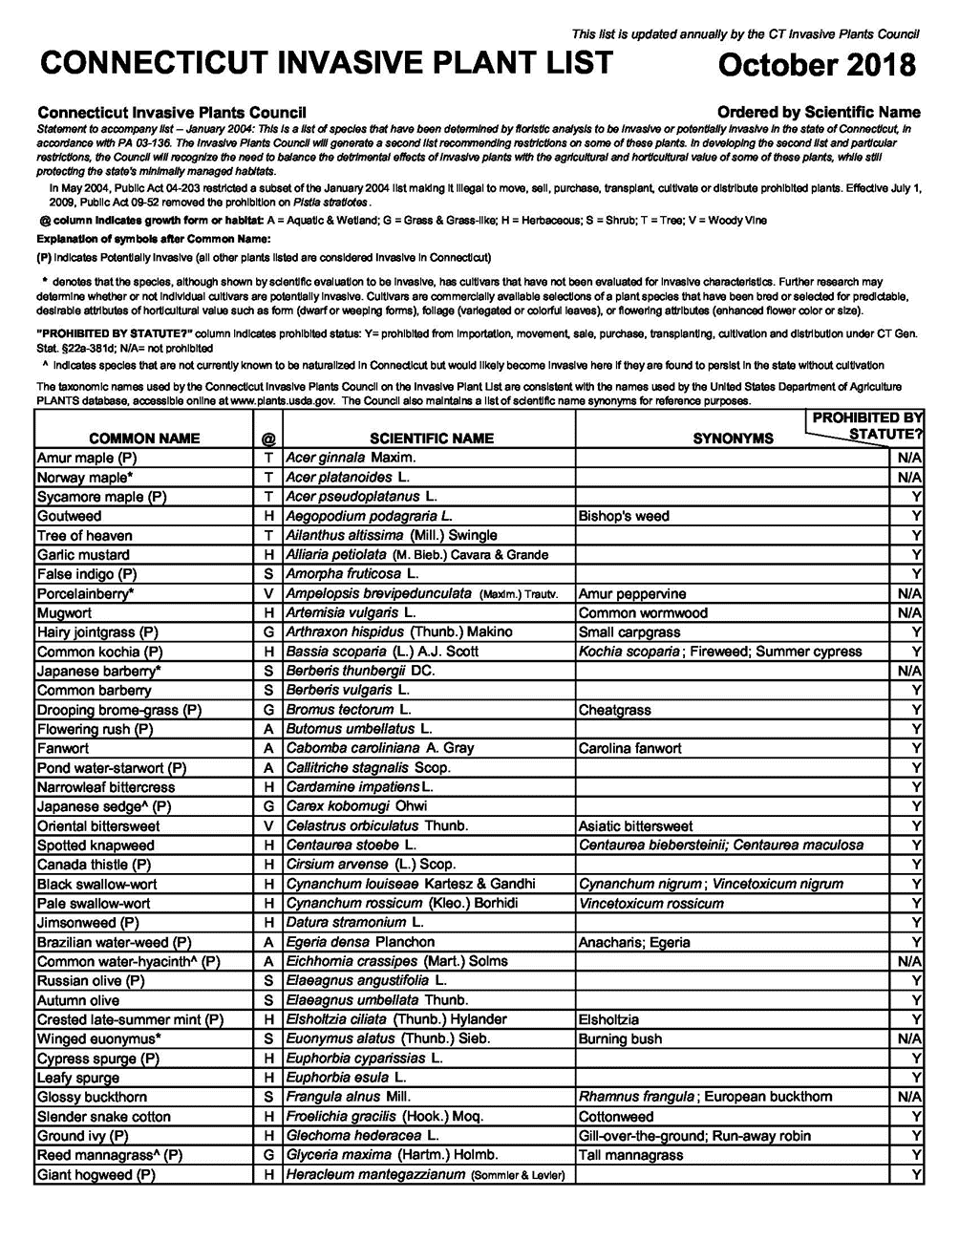

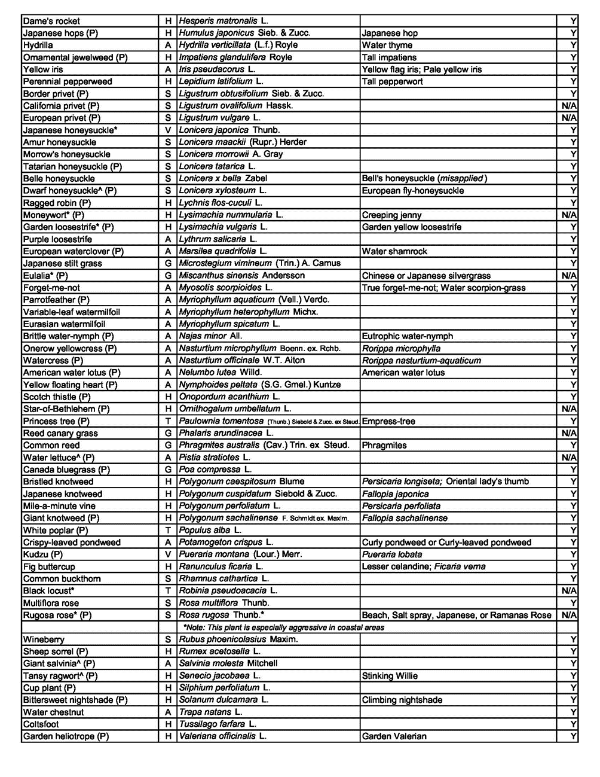

ATTACHMENT C
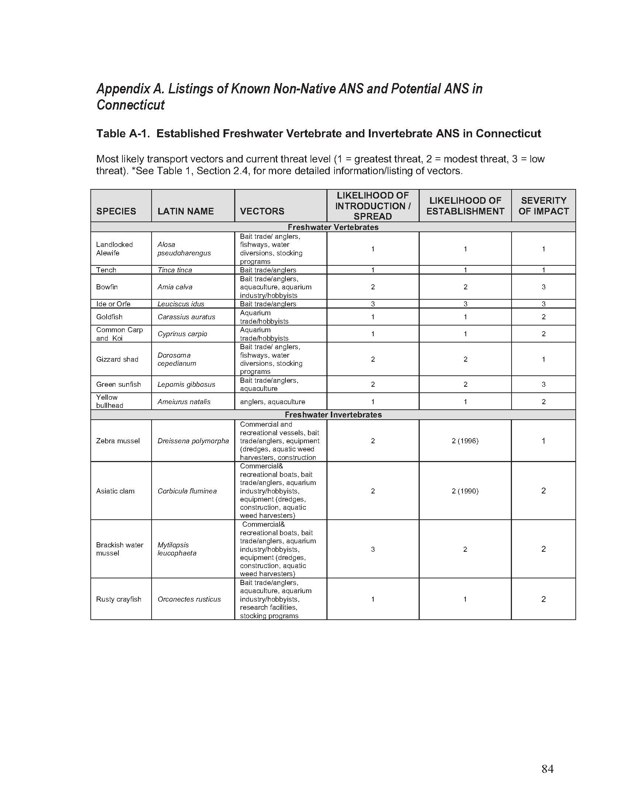

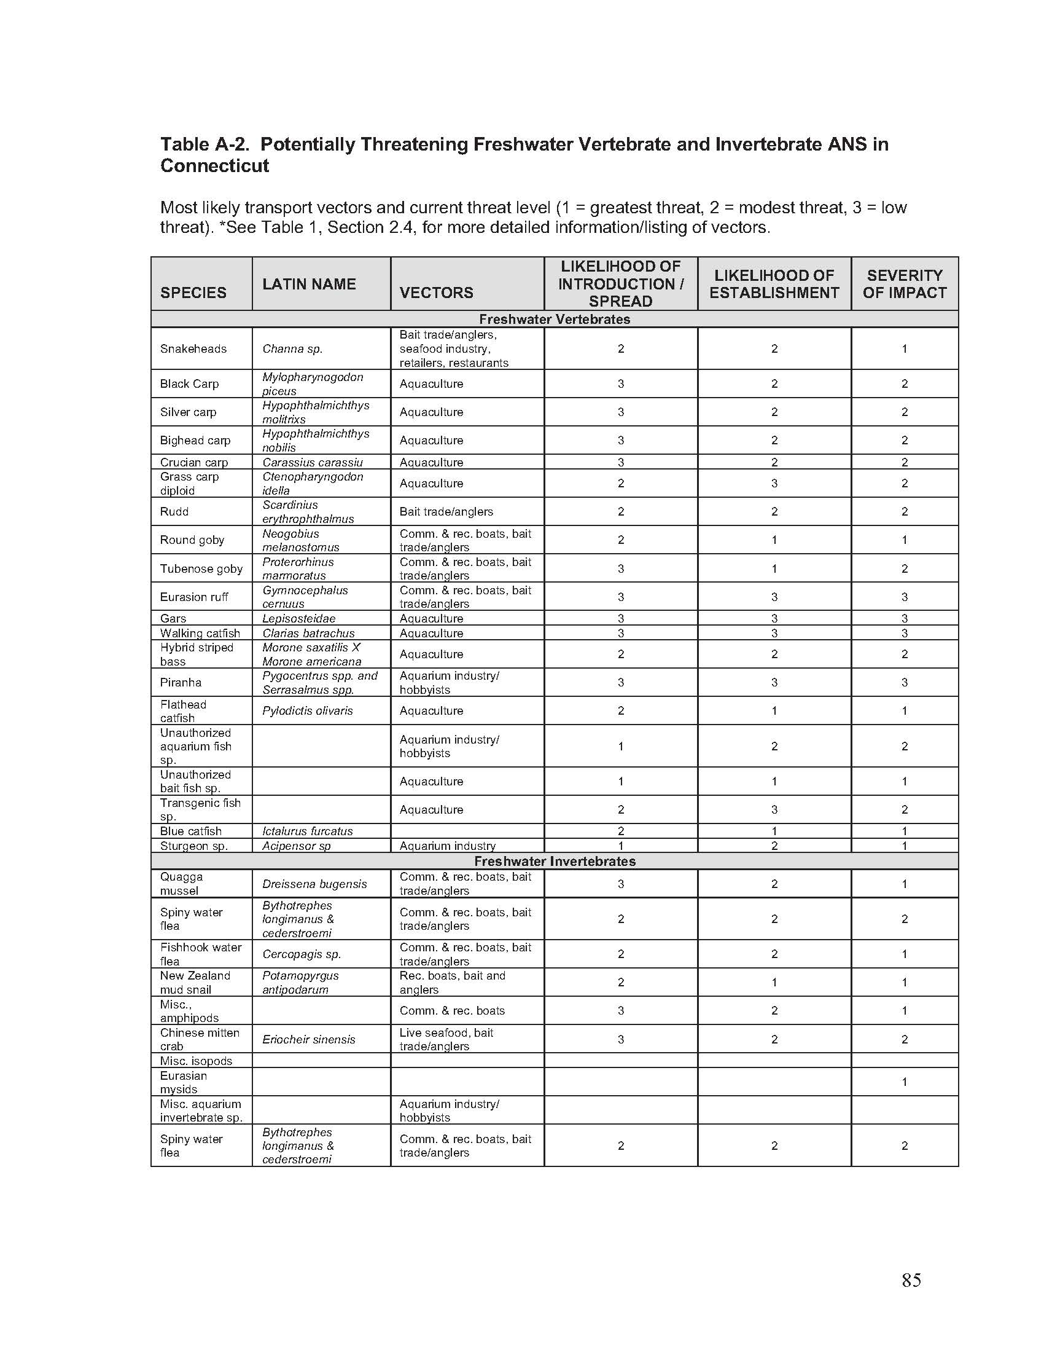

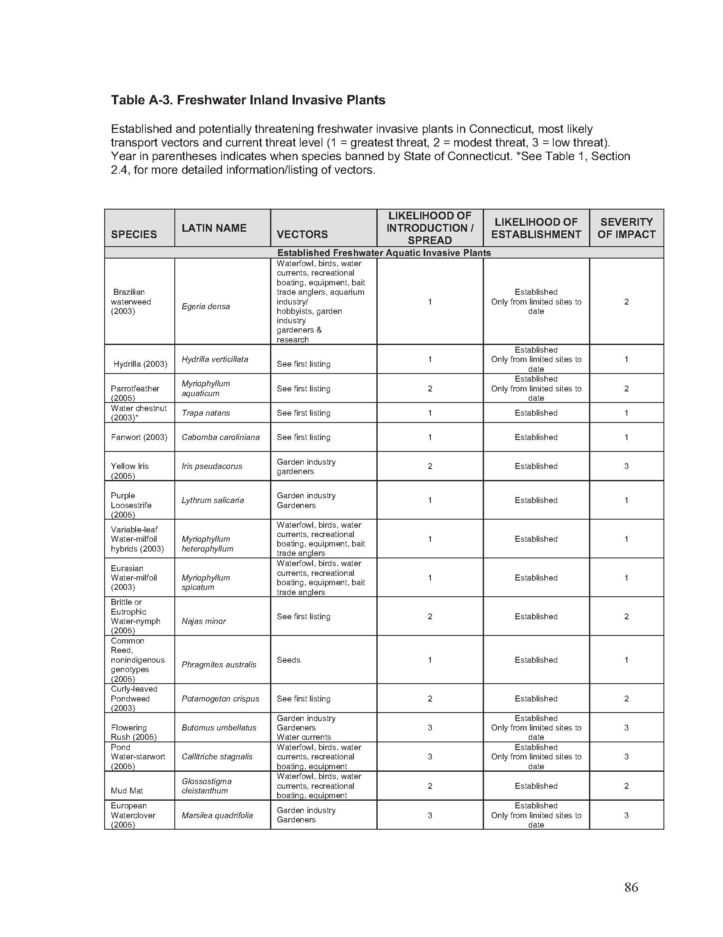

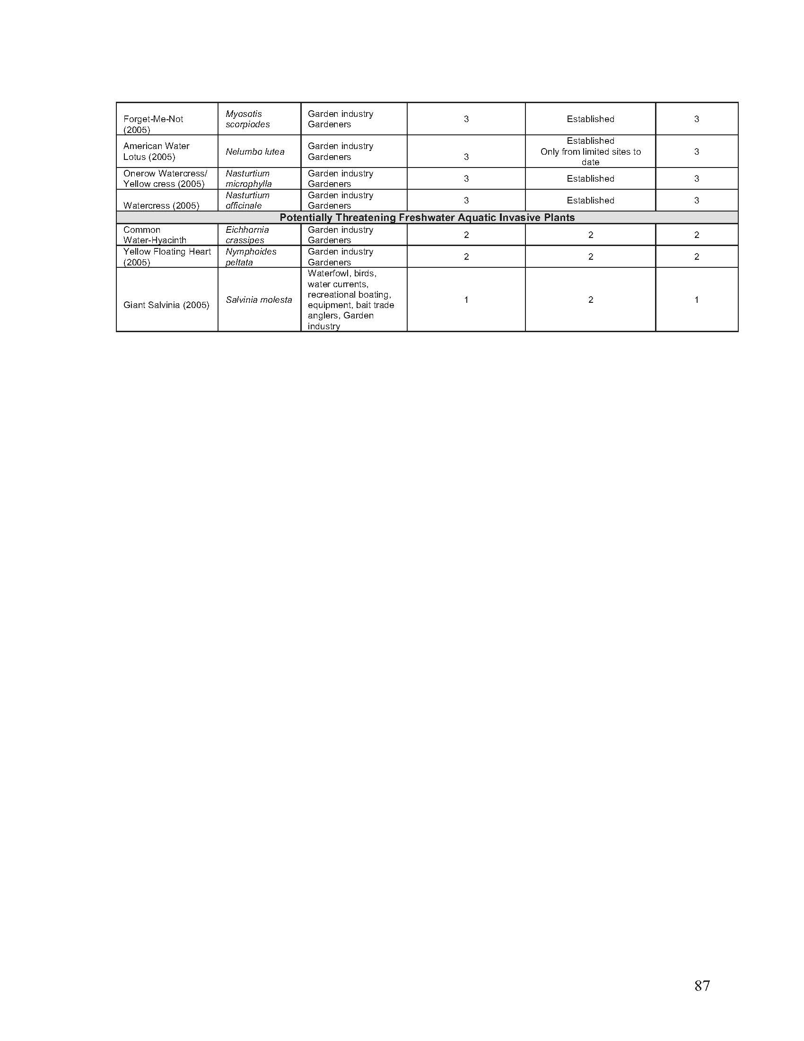

ATTACHMENT D



Grants for the Control of Aquatic Invasive Species Application Form

Part I: Applicant Information
1. Type of Applicant: State Agency Municipality Not-for-profit organization
Applicant Name: FEIN:
Mailing Address:
City/Town: State: Zip Code:
2. Contact Name:
Title:
Phone: *E-mail:
*By providing this e-mail address you are agreeing to receive official correspondence from DEEP, at this electronic address, concerning the subject application. Please remember to check your security settings to be sure you can receive e-mails from “ct.gov” addresses. Also, please notify DEEP if your e-mail address changes. DEEP is now using DocuSign to execute contracts.

Part II: Project Information
3. Title of Project:
4. Project Type (select the one that fits best): Control/Management Research Outreach/Education
5. Brief description of Project:

6. Total project cost:
7. Total grant funding requested:
8. Total matching funds (must equal or exceed 25% of the total project cost:
9. Name and location of study/project waterbody (as applicable):

Please include map of study/project waterbody Attached N/A
Please include map of the waterbody within the context of its watershed Attached N/A

Part II: Project Information (cont.)
10. Public Access and Use
Degree of access:

Facilities:

Please include map of facilities Attached N/A
Use patterns:
11. Waterbody Ownership:

Supporting ownership documents attached (check all that apply):
Tax Maps Other maps Easement Information Letters of Permission
12. Target Aquatic Invasive Species:

Supporting documents attached (check all that apply):
Photos Maps Survey Reports Studies

13. State-Listed Species
Consult with DEEP Natural Diversity Database (NDDB) Program at https://portal.ct.gov/DEEP/NDDB/Requests-for-NDDB-Environmental-Reviews
NDDB map showing project waterbody Attached N/A (education/outreach projects)
NDDB Determination (if state-listed species present)
Attached Pending (include documentation that indicates a review was requested)
Not Requested (but may require a review) N/A
14. Describe the purpose and need for the proposed project:

15. Describe the expected benefits of the proposed project:

16. Describe the scope of work (attach supporting documents if applicable):

17. For control/management projects describe any planned post treatment monitoring

Part II: Project Information (cont.)
18. For control/management please provide details on the long term management strategy for AIS and/or cyanobacteria in the project waterbody.

19. Define the schedule for completion of the scope of work for the proposed project:

20. Is this project a continuation of a project funded through an earlier iteration of this grant program?
Yes No
If yes, please note successes or limitations of the previous grant’s methodology and provide a brief narrative listing any updates to proposal methodology from the previous grant application(s):

21. Define the budget for implementation of the proposed project as applicable. Additional budget detail may be requested during the award and contracting phase:
Budget Summary
EXPENSES: | Grant Funds | Matching Funds
Personnel
Salaries: | $ | $
Fringe Benefits: | $ | $
Materials/Supplies: | $ | $
Travel: | $ | $
Contractual/Consulting Fees (specify): | $ | $
Equipment: | $ | $
Office Expenses/Printing and Copying: | $ | $
Other (please specify **): | $ | $
Total Grant Funds Requested: | $
Total Matching Funds Provided: |  | $
Total Project Costs: |  | $

22. Describe the availability of alternative funding, matching funds, or in-kind services:

Part III: Applicant Certification

The applicant must sign this part. An application will be considered incomplete unless the required signature is provided.
“I have personally examined and am familiar with the information submitted in this document and all attachments thereto, and I certify that based on reasonable investigation, including my inquiry of the individuals responsible for obtaining the information, the submitted information is true, accurate and complete to the best of my knowledge and belief.

I understand that a false statement in the submitted information may be punishable as a criminal offense, in accordance with section 22a-6 of the General Statutes, pursuant to section 53a-157b of the General Statutes, and in accordance with any other applicable statute.

I certify that this application is on complete and accurate forms as prescribed by the commissioner without alteration of the text.”

Signature of Applicant or Authorized Representative |  | Date
Name of Applicant or Authorized Representative (print or type) |  | Title (if applicable)

ATTACHMENT E

GRANT FUND APPLICATION INSTRUCTIONS
These application instructions have been designed to apply to all activities eligible for funding. Please read these instructions in their entirety and provide answers to each question in order by number. These instructions have been designed to minimize the potential for incomplete applications. Information required in items must be provided by filling out the attached application form using the space provided and additional sheets as needed.
The level of detail required to fully answer each question is related to the scale and scope of the proposed project. Applicants are requested to provide a thorough description of the proposed project and answer each question as it applies to the activity. Submission of complete and accurate information will enhance the chance of the proposal being selected for funding.
An electronic version (PDF file format) of the application and other documentation must be submitted to via email to DEEP.AISGrants@ct.gov. Applicants should refer to the full RFP document for complete application instructions, and scoring/review criteria.

DEADLINES: All applications and supporting documentation must be submitted via email to DEEP.AISGrants@ct.gov by December 06, 2024. Applications or supporting documents received after that date and time will not be considered.
Note: All of the questions must be answered. If a question is not applicable to your particular proposal, please provide a brief explanation. Do not leave the questions blank.

- TYPE OF APPLICANT:
  - Select the category that best describes the applicant. State agencies (including State Colleges and Universities), municipalities, and not-for-profit organizations are eligible to receive grants through this program. Local interest organizations such as unincorporated lake associations can develop project proposals in collaboration with municipalities or not-for-profit organizations but only the municipality in which the project water body is located or the not-for-profit organizations can apply for funding. Fill in the legal name(s), mailing address(es), and FEIN of the applicant agency, municipality, or organization. For applicants that are a 501(c)3 non-profit organization you must be registered with the CT Secretary of State. You can check your registration status here: Registering Your Business (ct.gov).

  - If the water body is located in more than one municipality, two or more municipalities may apply jointly, and a lake authority as established under sec. 7-151a of the Connecticut general Statutes may act as the agent of the member towns for the purposes of this grant program. If multiple municipalities are involved with a single project, a lead municipality must be identified.

- NAME, ADDRESS, PHONE NUMBER AND EMAIL ADDRESS OF CONTACT:
Fill in the name(s), title, mailing address(es), phone number(s), and e-mail address of the contact. Phone number(s) must be a number where the contact is reachable during business hours.
The contact person is the individual who is familiar with the project details and who should be contacted for additional information or questions. Should the project be funded, this is also the person who will be the primary contact during the course of the project through final completion and who is authorized to enter into a contract with DEEP.

- TITLE:
State the title of the proposed project.
The title should be concise and include project purpose/goal, target species, location and municipality all in one line (e.g. “Control of hydrilla from Happy Acres Park Pond, Wallingford, CT” or “Diagnostic Feasibility study of the yellow floating heart infestation in Shady Acres Lake, Enfield, CT”).

- PROJECT TYPE:

Select the project type that best fits the main scope of work. While some applicants may wish to incorporate elements from multiple project types, the review committee will only evaluate the proposal within the context of the selected project type.

- BRIEF DESCRIPTION:
Provide a brief (200 words or less) description of the proposed study, control/management project, or educational/outreach program. Include target species, study or control methods, timeline & duration of study and expected receivables (for research studies), size of water body, degree of public access, any project partners, and size/extent of infestation/area to be treated (for control/management projects).
e.g. The goal of this project is to control or eradicate water chestnut (Trapa natans) from a 20 acre pond. This plant was first found in this pond two years ago, and currently covers an estimated 5 acres. We propose to use herbicides (2, 4-d formulation) to initially treat the water chestnut. Additionally, a volunteer group will be established and trained to monitor the pond in subsequent years. Some Town staff will also attend training. The pond is an impoundment on a tributary to the “Big River”. Public access to the pond is through a town park located on the west shore of the pond. The park includes a boat launch suitable for canoes, kayaks and small boats, plus 500 feet of accessible shoreline for fishing.

- TOTAL PROJECT COST:

State the total cost of the project including both total grant funding requested and total matching funds

- TOTAL GRANT FUNDING REQUESTED:
State the total amount of grant funding requested. For determination of such an amount, refer to question 21 for an explanation of how to provide the budget for the proposed project.

- TOTAL MATCHING FUNDS:
State the total amount of matching funds committed for the proposed project. The maximum grant award is $75,000 and the lower limit is $10,000. Requests for larger grants may be considered, but only for exceptional and well-justified proposals. Matching funds are required and must equal or exceed 25% of the total project costs.

9. NAME AND LOCATION OF STUDY/PROJECT WATERBODY (as applicable).
Provide the name (names) of the target water body and the names of all municipalities within which the water body is located. Provide a map clearly showing the location of the water body and a description of its location as well as a map that shows the waterbody within the context of its watershed.

- PUBLIC ACCESS AND USE
Provide the following information concerning public access to and use of the water body:
- Describe the degree of access (is the water body fully accessible, open to access only in some seasons or at certain times of day, restricted to local residents, closed to all use, etc.). If access is restricted, please explain.
- Describe the facilities (parking, roads, trails, boat launches, marinas, shoreline access, picnic areas, wildlife viewing structures, fishing piers, etc.). Please provide map of water body showing locations of these facilities.
- Describe the use patterns (what are primary/most popular uses of property/water body?).

- WATER BODY OWNERSHIP
Provide information demonstrating any ownership or other legal interest in the water body, including:
- Copies of any Tax Map or Maps that show ownership (partial or full) of the affected water body.
- Copies of applicable conservation and other access easements.
- Letters of permission should be provided for any non-applicant properties which must be crossed to gain access to the water body.

- TARGET AQUATIC INVASIVE SPECIES
Provide information concerning target aquatic invasive species, including:
- The name(s) of target species. List both common names and scientific names.
- Names, contact information of individuals, consultants, businesses, organizations and agencies who identified or verified identification of these species.
- Documentation of the actual presence of the target species in the water body (attach photos, data from professional plant surveys, copies of relevant sections of reports and/or studies, etc.).

- STATE-LISTED SPECIES
Applicants should determine whether state listed species (endangered, threatened and special concern species and significant natural communities) in Connecticut are present within or near the study/project water body, and if the proposed project will affect state listed species.
- Please provide the DEEP Natural Diversity Data Base (NDDB) map for applicant town (or a GIS map that includes the current NDDB layer) showing location of study/project water body (if necessary, the location can be drawn & names of water bodies can be written on the map with an arrow to the correct location on the map). Maps can be accessed from the following website: https://portal.ct.gov/DEEP/Endangered-Species/Endangered-Species-ReviewData-Requests
- If NDDB map data indicates that state-listed species and/or significant natural communities are known to be present, please see the following guidelines:
  - If the project has already been through the NDDB review process, please attach any current, non-expired NDDB determinations to your grant application.
  - If the project has not yet been through the NDDB review process, Applicants should NOT, at this time, request NDDB determinations solely in conjunction with this grant application. However, if you expect your project to move forward regardless of whether funding from this grant is awarded (i.e. other funding sources have been secured), you should proceed with your request for NDDB review. For those projects dependent upon this AIS Grant for funding, the AIS Grants Oversight Committee may request NDDB determinations on behalf of applicants for projects that rate highly during the review process.
  - Education and outreach projects and some types of research projects (e.g. plant surveys) may not require an NDDB determination
- Applicants are advised that the NDDB review process may transition to a new electronic review system during the grants application submission period. The AIS Grants Oversight Committee will adjust expectations accordingly to accept any maps and/or determinations provided by the new review system.
Note that during sampling, research studies may actually provide information relevant to the NDDB such as determining the presence of additional state-listed species; and most control/management projects can be designed to avoid negative impacts to state-listed species and significant natural communities, and preference will be given to projects that can show a definite benefit to these species and communities.

- DESCRIBE THE PURPOSE AND NEED FOR THE PROPOSED PROJECT:
- Describe the purpose of, and need for the study or project, including a description of the extent of the infestation (as known at the time of submission) and its current or potential impact on native species, fish and wildlife habitat, recreational uses and aesthetic values.
- Describe any past studies or efforts to control/eradicate the target species on the project water body.

- DESCRIBE THE EXPECTED BENEFITS OF PROPOSED PROJECT:
- Describe the expected ecological, recreational, and watershed scale benefits of the proposed project.
- For education/outreach projects, describe how the project is designed to effectively reach the target audience.

- DESCRIBE THE SCOPE OF WORK:
Describe the scope of work identifying each task, product and service. Where applicable, include site maps and/or other diagrams indicating location and features of specific study or project tasks. Please at a minimum include the following information:

For all proposals-
- Whether federal, state, municipal and/or other legal entities (for which coordination may be necessary, such as power utilities, dam owners, etc.) approvals, authorizations (i.e. permits) are needed (and the status of any requests for permits). Preferred studies and projects have either obtained, or can obtain in a timely fashion all necessary approvals, authorizations and/or permits. Attach copies of any permits already obtained. Note that awardees will be required to submit copies of permits obtained following the awarding of funds.

For research studies:
  - Study timeline.
  - Study methodology and field resources expected to be committed to the study.
  - Data analysis and mapping resources available to be committed to the study.
  - Expected study products.
  - Summary of ability of applicant to implement study findings and recommended actions.

For control/management projects:
  - Plans for pre-control monitoring.
  - Narrative of the distribution/concentration or areal extent of target species coverage and a description of the site(s).
  - Map(s) and photographs (when available) of the water body clearly showing the distribution of target species and areas targeted for control. Also clearly show on the same map locations of known populations of state-listed species.
  - Description of all control methods to be used, including where each method will be used and how frequently during the course of the project. Also indicate who will be performing the various controls (i.e., licensed applicator/consultant services, volunteers, municipal staff, NGO). Please list separately and be as specific as possible:
  - All pesticides and other chemicals to be used (if known at time of submittal).
  - All mechanical methods to be used (hand-pulling, suction harvester, hydroraking, etc.)
  - All bio-control measures (grass carp, “milfoil” weevil, etc.).
  - Discuss how state-listed species or significant natural communities will be protected during the project.
  - Expected outcome of control measures. Include an estimate of the reduction in population size/concentration and/or area (i.e., acres, square meters or feet) of, or length (i.e. feet, yards, meters, miles of river bank or lakeshore) of target species controlled or eradicated.
  - Discuss whether any changes in public access will occur due to this project.
  - Plans for notifying/educating users and general public.
  - A discussion of plans for rehabilitation/revegetation/restoration of targeted sites when such actions may be warranted.
  - Proposals that include work with sub-contractors to apply herbicides for invasives management must comply with the following:
    - Adhere to relevant state statutes and regulations including but not limited to: CGS §§ 22a-54 , 22a-66(l) and 22a-61, relevant sections of CGS Chapter 441, and RCSA 22a-66a.
    - Provide documentation of the sub-contractor's business registration and pesticide certification. Proposed herbicide use in or immediately adjacent to bodies of water will require aquatic permits and certifications will be required in accordance with CGS § 22a-66z.

    - Publish a notice of pesticide application in a newspaper of general circulation in each municipality in which the lake or pond is located and install signage per state pesticide regulations, requirements of CGS § 22a-66a(h) and RCSA 22-66a.

Please see the following links for more information about pesticide certifications in Connecticut, and other resources.
- Aquatic Weed Control Certification Information (ct.gov)
- License Lookup (ct.gov): Look up the registration of pesticide applicators in CT
- Safety and Herbicides | Connecticut Invasive Plant Working Group (uconn.edu)

- FOR CONTROL/MANAGEMENT PROJECT DESCRIBE ANY PLANNED POST TREATMENT MONITORING:

Briefly describe any planned post treatment monitoring including both project funded monitoring as well as any long term monitoring expected to occur after the contract period.

- FOR CONTROL/MANAGEMENT PROJECTS PLEAS PROVIDE DETAILS ON THE LONG TERM MANAGEMENT STRATEGY FOR AIS AND/OR CYANOBACTERIA IN THE PROJECT WATERBODY:

Describe or attach any long-term management plans including procedures for continued control and spread prevention the target aquatic invasive species, or if the goal is eradication, a long-term management plan to prevent the reestablishment of the target species.

- DEFINE THE SCHEDULE FOR COMPLETION OF THE SCOPE OF WORK FOR THE PROPOSED PROJECT:
Provide a proposed schedule for completion of each phase of the project as it corresponds to the scope of work described and the total number of months needed to complete the project. Clearly list each major activity to be performed (e.g. vegetation surveys, herbicide treatments, etc.), identify who will be responsible for performing each activity, and indicate when each activity will be performed. Identify any seasonal constraints or specific requirements for work scheduling. For example, work times may need to be coordinated with target species growing season, observation of environmentally sensitive periods, or the receipt of required authorizations.
Please note that projects should generally be completed within one year from the contract execution date. It is anticipated that the contracts will be mailed to award recipients for review and signature within two months of the grant award announcement. Within approximately six weeks from the date DEEP receives the signed contract and all necessary resolutions or other attachments, the contract will be able to be fully executed, and funding can be made available for use by the recipient. Only expenses incurred following a properly executed contract will be deemed eligible expenses. Such a timeline should be taken into account in determining a proposed schedule for the project.

- IS THIS PROJECT A CONTINUATION OF A PROJECT FUNDED THROUGH AN EARLIER ITERATION OF THIS GRANT PROGRAM?
Select yes or no. If yes, please note successes or limitations of the previous grant’s methodology and provide a brief narrative listing any updates to proposal methodology from the previous grant application(s):

- DEFINE THE BUDGET FOR IMPLEMENTATION OF THE PROPOSED PROJECT:
Using the budget summary, provide a list of the expenses for the proposed project. In addition, on a separate sheet, provide a brief narrative explaining each line item expense requested from the Grant Fund. Indirect costs associated with projects may be used as matching funds. However, Grant Funds cannot be used for indirect costs.
The maximum grant award is $75,000. For projects which are more expensive or in order to guarantee the continuation of the proposed project beyond the initial year of its implementation without Grant Fund support, matching funds or alternative funding should be considered. Requests for larger grants will be considered, but only for exceptional and well-justified proposals. Any work subcontracted must be arranged through a competitive selection process unless there is a demonstration of the need for a sole source.
A 50% payment of the grant amount will be initiated following execution of the contract with the remaining balance due after the applicant demonstrates expenses (including match) beyond the value of the execution payment. Following completion of the project, a report including documentation that all the elements of the project have been completed, the outcome of the project and a financial summary indicating expenses incurred must be submitted to DEEP. Projects that come in under budget or fail to meet contract obligations are required to return all unused funds to DEEP.

- DESCRIBE THE AVAILABILITY OF ALTERNATIVE FUNDING OR MATCHING FUNDS OR IN-KIND SERVICES:
Provide a description of matching funds, in-kind services and the availability of alternative funding. Matching funds may consist of actual funds as well as other contributions such as in-kind services, materials and volunteer labor.
Applicants are encouraged to demonstrate a commitment to continue the proposed project beyond the initial year of its implementation without additional DEEP funds. Funding for well-matched projects will be viewed favorably, and a demonstration of a commitment of future funding for that purpose is strongly encouraged.

- CERTIFICATION OF AUTHORIZED REPRESENTATIVE:
State the name and title of the representative who, if the contract is awarded, is legally authorized to sign the contract on behalf of the municipality. Have this individual sign and date the application form in the space provided. Applications which are not signed by a legally authorized individual shall not be accepted and will be deemed ineligible for further consideration. The applicant must also supply a signature resolution indicating that the signer is authorized to sign legal documents and enter into contracts on behalf of the municipality.

