Response to Comments
Regarding State Implementation Plan Revisions concerning
PM2.5 Maintenance Plan for New Haven and Fairfield Counties

On January 11, 2023, the Commissioner of the Department of Energy and Environmental Protection (DEEP) published notice of intent to revise the State Implementation Plan (SIP) for air quality to address the requirements under sections 175A(a) and (b) of the Clean Air Act (CAA) for areas that have been redesignated from nonattainment to attainment (i.e. maintenance areas). This is the second 10-year plan to assure continued maintenance of the National Ambient Air Quality Standards (NAAQS) for fine particulate matter (PM2.5) in the Connecticut portion of the New York-New Jersey-Connecticut (NY-NJ-CT) maintenance area. Pursuant to such notice, the proposed SIP was open for comments and a public hearing was scheduled for February 22, 2023, provided such a hearing was requested. No such request was received, and the hearing was cancelled on February 15, 2023. The public comment period remained open through February 22, 2023.

This report addresses the comments received on the proposed implementation plan revisions during the comment period and final recommendations for the plan revision.

Written comments were received from the following persons/organizations:

1. Eric Wortman, Acting Manager
Air Quality Branch
U.S. EPA, Region 1
5 Post Office Square, Suite 100
Boston, MA 02109-3912

All comments submitted are available on the DEEP website, together with the proposed and revised SIP. Summary of the comments appear below with DEEP’s responses.

Comments by Eric Wortman/EPA

Comment: On page 11 (Figures 2-1 and 2-2), the overall trendlines of the design values for all sites show a clear decrease since 2002, but there appears to have been a slight increase since 2019. Connecticut DEEP could consider adding an explanation for this increase in monitor readings, and how this increase will not affect the State recording any monitor or design value violations.

Response: While the mild increase after 2019 is not outside the normal fluctuations seen within the data, any increase in monitor readings is concerning to DEEP. This increase was investigated and DEEP observed that data in 2020 and 2021 were abnormally high on multiple days that correlated with smoke impact to Connecticut from western wildfires. The slight upward trend, though noticeable, does not indicate concern for continued maintenance of the standards, as concentrations are sufficiently below critical design values and National Ambient Air Quality Standards

As preliminary design values are now available from the EPA Air Quality System Preliminary Data Report, we have included the 2022 data in our trends. The 2022 data does not indicate concern for generally increasing trends. Updated charts, included on page 11 of the revised SIP, are shown following the next comment.

Comment: The Plan’s monitor and design value graphs are missing data for the Waterbury monitor for 2018. It would be useful for the public for Connecticut DEEP to include an explanation for why there is no data for this year for this monitor.

Response: The Waterbury site was undergoing reconstruction from April 15, 2016 through July 29, 2016 and could not collect data during that time. This resulted in incomplete data for 2016, which affected both 24-hour and annual design values for 2016-2018. To clarify this point, language was changed on page 14 from “Five years of design values (seven years of data) were used for three of the four Connecticut monitors and three years of design values (5 years of data) were used for the Waterbury monitor” in the proposal, to “Five years of design values (seven years of data) were used for three of the four Connecticut monitors. Three years of design values (5 years of data) were used for the Waterbury monitor due to site reconstruction activities resulting in incomplete data for 2016 and invalidating design values for 2016-2018”.

While reviewing this comment, it was recognized that the proposed SIP included invalid Waterbury design values for 2016 and 2017 in Figure 2-1 showing the 24-hour PM_{2.5} design value trends. Figure 2-1, on page 11, has been corrected to reflect only valid design values and thus omits design values from 2016 to 2018 consistent with Figure 2-2 for annual design values.

The critical design values for Waterbury were calculated without use of the invalid design values and no changes to critical design values result from these changes to the figures.

The changes to the design value trends in Figures 2-1 and 2-2 resulting from the above comments are shown below.

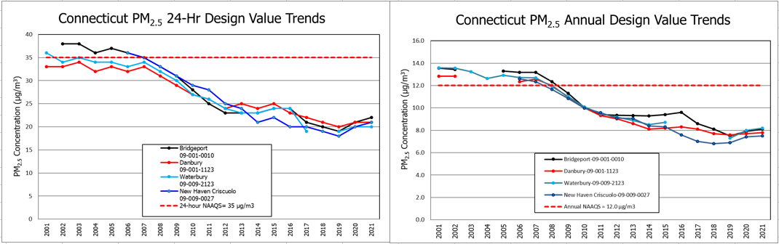
As result of comments received, the figures on page 11 of the of the SIP as proposed for hearing (shown below) which included insufficient data have been removed and replaced as described herein.
Figure 2-2. Annual Design Value Trends for Connecticut Monitors in the NY-NJ-CT Maintenance Area.

Figure 2-1. 24- Hour Design Value Trends for Connecticut Monitors in the NY-NJ-CT Maintenance Area.

Page 11 of the SIP has been revised to include the following figures replacing the figures above.
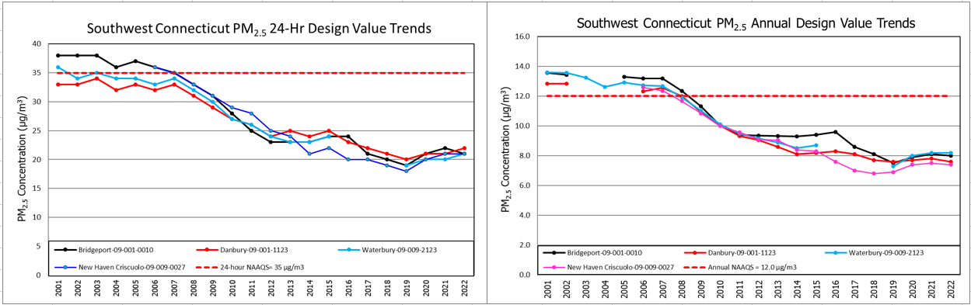
Figure 2-2. Annual Design Value Trends for Connecticut Monitors in the NY-NJ-CT Maintenance Area (2022 Design Values are preliminary).

Figure 2-1. 24- Hour Design Value Trends for Connecticut Monitors in the NY-NJ-CT Maintenance Area (2022 Design Values are preliminary).

Comment: In addition to the graphs included in page 11, EPA suggests Connecticut DEEP include tables of the numbers and data used to generate the graphs.

Response: The purpose of the graph is to visually demonstrate the more than adequate margin between design values and standards. Interested readers can find relevant valid design values below, as well through EPA’s Design Value Interactive Tool. DEEP has revised the SIP to included a footnote and link to EPA’s design value tool at the end of the last paragraph on page 10 introducing the graphs. The footnote reads: “Design values can be found at EPA’s website: Design Value Interactive Tool | US EPA”

 | Bridgeport 09-001-0010 |  | Danbury 09-001-1123 |  | New Haven Criscuolo 09-009-0027 |  | Waterbury 09-009-2123
Year | Annual DV | 24-hr DV | Annual DV | 24-hr DV | Annual DV | 24-hr DV | Annual DV | 24-hr DV
2001 | 13.6 | 38 | 12.8 | 33 |  |  | 13.6 | 36
2002 | 13.4 | 38 | 12.8 | 33 |  |  | 13.6 | 34
2003 |  | 38 |  | 34 |  |  | 13.2 | 35
2004 |  | 36 |  | 32 |  |  | 12.6 | 34
2005 | 13.3 | 37 |  | 33 |  |  | 12.9 | 34
2006 | 13.2 | 36 | 12.3 | 32 | 12.6 | 36 | 12.7 | 33
2007 | 13.2 | 35 | 12.6 | 33 | 12.4 | 35 | 12.7 | 34
2008 | 12.4 | 33 | 12.0 | 31 | 11.7 | 33 | 11.9 | 32
2009 | 11.3 | 31 | 11.0 | 29 | 10.8 | 31 | 11.0 | 30
2010 | 10.0 | 28 | 10.0 | 27 | 10.0 | 29 | 10.1 | 27
2011 | 9.4 | 25 | 9.3 | 26 | 9.6 | 28 | 9.5 | 26
2012 | 9.4 | 23 | 9.0 | 24 | 9.1 | 25 | 9.2 | 24
2013 | 9.3 | 23 | 8.6 | 25 | 9.1 | 24 | 8.9 | 23
2014 | 9.3 | 23 | 8.1 | 24 | 8.4 | 21 | 8.5 | 23
2015 | 9.4 | 24 | 8.2 | 25 | 8.3 | 22 | 8.7 | 24
2016 | 9.6 | 24 | 8.3 | 23 | 7.6 | 20
2017 | 8.6 | 21 | 8.1 | 22 | 7 | 20
2018 | 8.1 | 20 | 7.7 | 21 | 6.8 | 19
2019 | 7.5 | 19 | 7.6 | 20 | 6.9 | 18 | 7.3 | 19
2020 | 7.9 | 21 | 7.7 | 21 | 7.4 | 20 | 8.0 | 20
2021 | 8.1 | 22 | 7.8 | 21 | 7.5 | 21 | 8.2 | 20
2022 | 8 | 21 | 7.6 | 22 | 7.4 | 21 | 8.2 | 21

Conclusion

Based on the comments submitted by interested parties and addressed in this report, I recommend that the SIP revision, revised as recommended in this report, be submitted to EPA for approval.

/s/ Daniella Lopez March 30, 2023
Daniella Lopez Date

https://portal.ct.gov/DEEP/Air/Planning/Particulate-Matter/PM25-Planning-Efforts-Attainment-Designations
https://www.epa.gov/aqs
Design values can be confirmed at https://www.epa.gov/air-trends/design-value-interactive-tool

